Table of Contents

**Introduction**3

**Water Management Goals**4

**Developing the Rationale for Instream Flow Management Prescriptions** 5

**Hydrology**6

***Riparian Zone***11

***Valley Form and Floodplain Maintenance***14

**Geomorphology**15

***Channel Form***16

***Sediment Transport***20

**Biology**20

***Life History Cues***21

***Hydraulic Habitat***23

**Water Quality**30

***Temperature***32

***Fine Sediment***34

**Connectivity**36

***Nutrient Cycling and Pathways***37

***Fragmentation and Its Effect on Fish Movement***42

***Disconnections Caused by Changes in Water Quality***42

***Estuarine Production***43

**Ecological Considerations for Habitat and Scale**45

***Spatial Scales***45

*The Global Scale*45

*The Watershed Scale*45

*The Stream Segment Scale*46

*The Macrohabitat Scale*46

*The Mesohabitat Scale*46

*The Microhabitat Scale*46

***Temporal Scales***47

**Lessons from Stream Ecology**48

***The Importance of Flow Variability***49

***The Need for Ecosystem-Level Management***51

**Water Appropriation Permits – Recommendations and Rationale** 54

**A. Critical Elements of Sustainable Water Management**54

***1) Surface Water and Groundwater are Linked***54

*Surface Water (Streams, Lakes, and Wetlands)*54

*Groundwater*55

*Interactions Between Groundwater and Surface Waters*55

*Recharge*56

***2) Stream, Lake, and Wetland Ecology is Intimately Linked to the Hydrograph – Summary and Relation to Management***56

**B. Integrating Principles into a Management Approach**57

***1) Limiting Total Water Withdrawals – the Sustainable Diversion Limit (SDL)***58

*Recommendation for a Sustainable Diversion Limit (SDL)*58

*Flow Ecology Response Curve (Richness)*59

*Flow Ecology Response Curve (Habitat)*64

*Sustainable Diversion Limit (SDL)Recommendation*68

*Why a 15% of August Median Flow SDL?*68

***2) Protected Cutoff Level***68

***3) Adaptive Environmental Assessment and Management: A Necessary Complement to Sustainable Water Management***69

**References**70

**Appendix A: Specific Recommendations for Changing State Statutes and Rules, Relative to Goal of Sustainable Water Management**84

**Appendix B: Fish Species Richness/ Flow Model and Output**89

**Water Appropriation Permits – Recommendations & Rationale**

Given that our goal is to maintain a sustainable water supply, operationally, that entails preventing significant harm to ecosystem health as a result of water abstraction. We are identifying a balance among current and future users, off-stream users and current ecological conditions by acknowledging that there is a limit to the amount of water that can be withdrawn directly from the surface or through connected groundwater surface water systems. With sustainability as a goal, protecting natural flow variability is a fundamental component of our water management. The following section lays out the critical principles to consider and incorporate as we work towards sustainable water management, and outlines an approach to integrate these principles into management. We believe these elements, when taken together, will balance off-stream use while avoiding significant harm to ecosystem health. Following are a detailed description of the critical principles and a proposal to integrate these principles into a sustainable water management approach.

**A. Critical Principles of Sustainable Water Management**

If we are to be ultimately successful in managing our water resources over the long run, a number of elements must be recognized and explicitly incorporated. They include:

1. Protecting ecosystems while allowing use of resources requires that management identifies and protects the threshold for ecosystem harm.
2. The ecological structure and function of watersheds, as well as the services they provide, are tied to the hydrograph of a landscape and its variability.
   1. Must protect the entire hydrograph and its variability
   2. Must protect within year variability and between year variability.
3. Surface water and groundwater are a single resource and limited.
   1. both must be protected, singly, and relative to each other (i.e., stop groundwater withdrawals that affect surface waters and visa versa).
   2. stopping drainage of some surface waters may be critical to recharge of groundwater aquifers (designate recharge zones?)

Each of the above principles are discussed briefly below.

1. ***Sustainable Ecosystem Boundaries and Thresholds***

Addressing the issue of preventing harm to ecosystems ultimately references the goal of sustainability. Strong relationship has been established between both fish species richness and fish habitat with stream flow in Minnesota (see Section B., below). When water is removed from streams, the structure and function of their ecology is altered. At some point, increasing alteration of natural flows degrades the health of the stream.

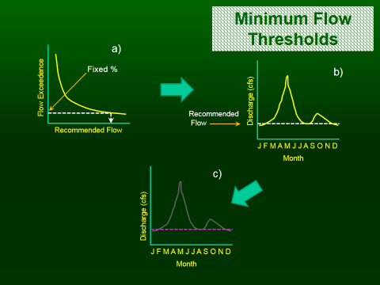In the past, stream flows were set based on fixed percentages of hydrologic variables (a) and represented “minimum flows”, essentially addressing, “what is the minimum flow required for the species to survive”. The recommended minimum flow value was set for the entire year (b). As demand increases, the result is a “flat line” (c), instead of the variable hydrograph. These management prescriptions have been demonstrated to lead to degradation of the biota and stream itself (e.g., not accounting for channel maintenance flows, riparian maintenance, or habitat needs).

The basic challenge is the difficulty of determining how much alteration from natural flows can be tolerated without compromising ecological health and ecosystem services (Richter et al. 2011). To prevent this degradation, a threshold that limits water use is selected, based on a percentage of flow. The advantage of using a percentage of flow approach is that it is conceptually simple, can provide a high degree of protection for natural flow variability, and can also be relatively simple to implement (Richter et al. 2011). Evidence that a 10% flow alteration is likely to have a negligible effect on most taxa, stream types, and hydrologic conditions is generally agreed on by experts (Acreman and Ferguson 2010, Figure 53). A high degree of ecological protection will be provided when daily flow

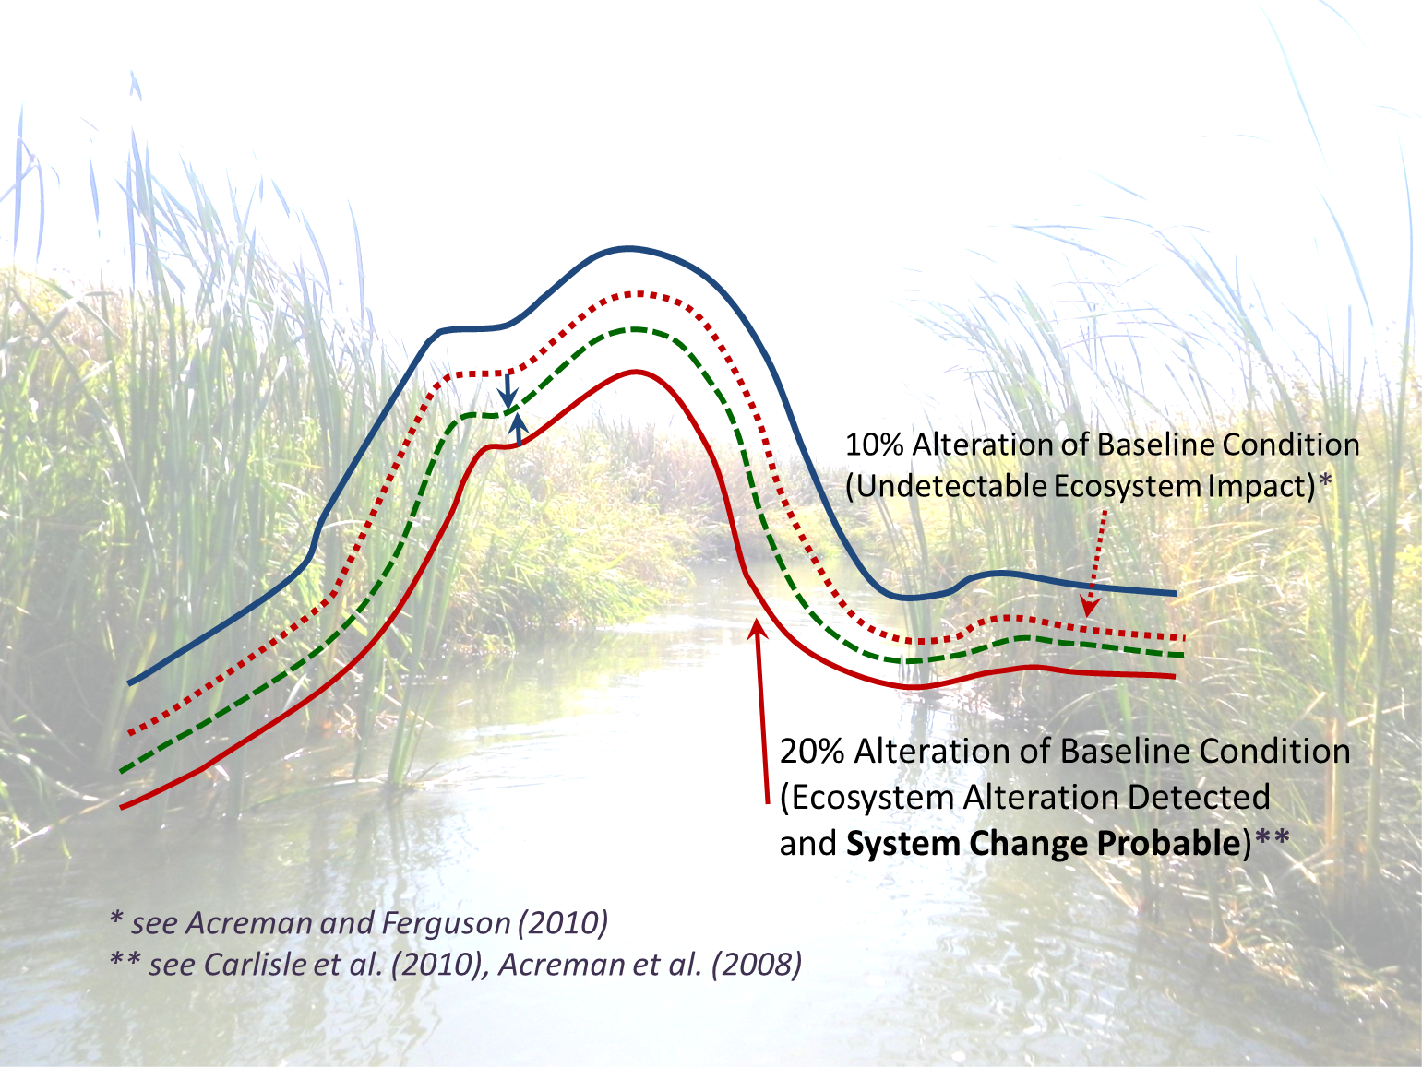

**Figure 53**. Illustration of the sustainable ecosystem boundary and thresholds for depletion limits (modified from Richter et al. 2011). Shown is an idealized natural hydrograph, establishing the baseline ecological condition (blue line at top); the red dotted line represents a 10% depletion of the baseline condition. Note here that there is an undetectable ecosystem impact. Alternately, water appropriations of 20% or greater, shown by the solid red line here, will likely result in moderate to major changes in natural structure and function of ecosystems (Carlisle et al. 2010, Acreman at al. 2008). The 15 % flow depletion threshold being proposed is shown as a dashed green line (also identified by blue arrows) and is simply a compromise between these boundaries. See text for additional explanation.

alterations are no greater than 10%; a high level of protection means that the structure and function of the riverine ecosystem will be maintained with minimal changes (Richter et al. 2011). Alternately, water appropriations of 20% or greater will likely result in moderate to major changes in natural structure and function of ecosystems. The 15 % flow alteration threshold is proposed simply as a compromise between these boundaries, striking a balance between current and future users, off-stream users, and current ecological conditions.

**2)** ***Stream, Lake, and Wetland Ecology are Intimately Tied to the Hydrograph and its Regime***

As presented in the above review, hydrology (the natural flow regime), is the key driver of river ecosystems and impacts to hydrology are seen as one of the most serious threats to rivers (Hill et al., 1991; Poff et al., 1997; Bunn and Arthington, 2002). All parts of the hydrograph are functionally important; in a real sense, there is no excess water (Hill et al. 1991, Figure 54).

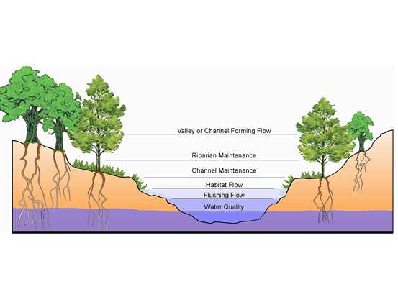

***Figure 54***. Effective river management refers to more than keeping a minimum amount of water in the channel to maintain fish survival. A range of river flows provides specific, important ecological functions that can be related generally to the five riverine components. Preservation of river flow variability—properly timed—is essential to sustaining river structure and function and ecosystem health. The types and relative levels of flow shown above are examples of the various flows that might be needed for any individual river and are not intended as a standard to be applied to every stream and situation (Source: Karim Aziz, Texas Parks and Wildlife Department).

The naturally variable flow regime creates and maintains the physical habitat in streams and the longitudinal and lateral connectivity (Junk et al., 1989; Poff et al., 1997; Montgomery and MacDonald, 2002). In addition, the natural hydrograph of streams influences the biology of rivers through several inter-related mechanisms (Figure 55). For example, species have evolved life histories that depend on the predictable seasonal variation in discharge (Bunn and Arthington, 2002). Hydrology also plays an important role in the transfer of energy between the floodplain and the river channel; it is also an integral factor influencing the plant species distribution in riparian areas (Hupp and Osterkamp, 1985; Auble et al., 1994). Bankside vegetation provides habitat and acts to control erosion and nutrient transfer (Annear et al., 2004). Hupp and Osterkamp (1985) and Auble et al. (1994) point to the importance of frequency of flooding and the duration of inundation. Poff et al. (1997) describes five components of a flow regime that influence river ecosystems: magnitude, frequency, duration, timing, and rate of change. Alteration of any one component can directly impact physical habitat (e.g., eliminating flood peaks will decrease the streams ability to move sediment) and aquatic organisms (e.g., increasing the rate of change will displace invertebrates and can result in stranding).

From a management perspective, groundwater is overwhelming important - to both surface water resources and human uses of freshwater. The natural flow regime in surface waters is connected to and interacts with associated groundwater aquifers. Because of this fact, depletion of the surface waters from groundwater pumping impacts the ecology of surface waters, by altering the structure and function of these systems. The dominant influence of hydrology in natural aquatic ecosystems and the singular nature of the water system imply that sustainable water management should be designed to maintain a natural flow regime even in the presence of high levels of off-stream and in-stream water use. A system that protects the

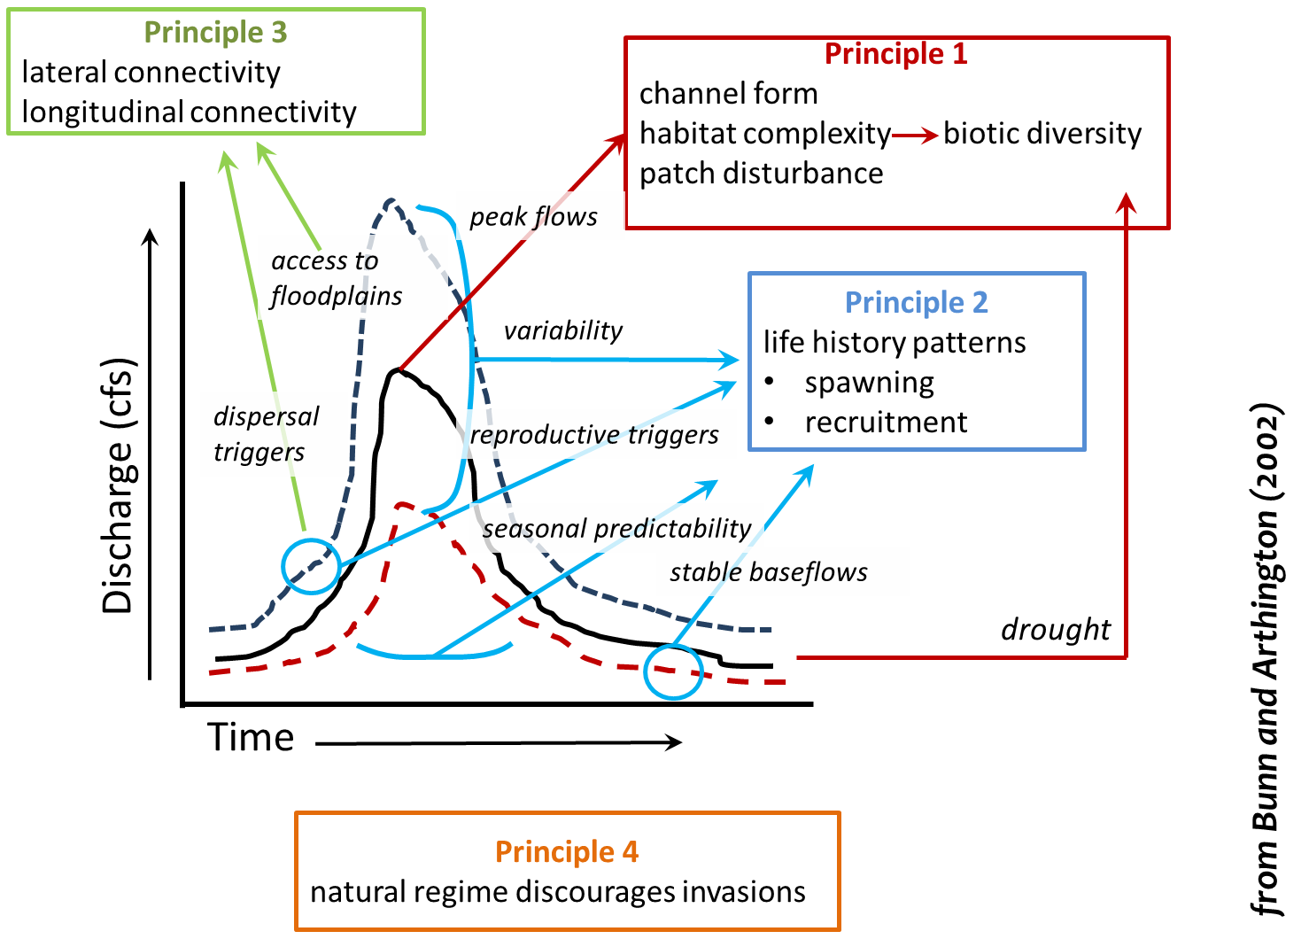

***Figure 55***. The natural hydrograph of streams and rivers influences the biology of rivers through several inter-related mechanisms. The biota have evolved in response to the overall flow regime. As organisms have adapted to the variability, they have become linked to the hydrograph. The relationship between biodiversity and the physical nature of the **aquatic habitat is likely to be driven primarily by large events** that influence channel form and shape (graph principle 1). However, **droughts and low-flow events** are also likely to **play a role by limiting overall habitat availability**. **Many features of the flow regime influence life history patterns**, especially seasonality and predictability of the overall pattern, but also the timing of particular flow events (graph principle 2). Some **flow events trigger longitudinal dispersal of migratory aquatic organisms and other large events allow access to** otherwise disconnected **floodplain habitats** (graph principle 3). Catchment landuse change and associated water resource development can often lead to changes in one or more aspects of the flow regime resulting in declines in aquatic biodiversity via these mechanisms. **Invasions by introduced or exotic species are more likely** to succeed at the expense of native biota **if** the former are adapted to the **modified flow regime** (graph principle 4; *from* Bunn and Arthington 2002).

critical components of the hydrograph (duration, magnitude, timing, frequency, and rate of change), throughout their range, would include at least 2 aspects: 1) a cap or limit on the cumulative amount of water that can be withdrawn in a watershed which protects natural variability of flows over time, i.e., hydrograph shape, and 2) a protected cutoff level, which protects against exacerbating extreme low flow conditions. The cap and protected flow combination are designed mostly to address impacts related to streamflow depletion.

FISH ARE SURROGATES for the ecosystem and for the ability of human society to endure and flourish.

Sustainability = ecological function and integrity

**3)** ***Surface water and groundwater are linked***.

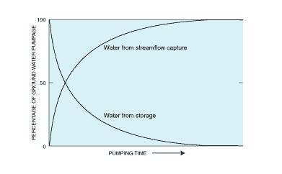

***Figure X.*** *The principle source of water to a well can change with time from groundwater storage to capture of streamflow. (from Winter 1et al. 1998).*

Water is central to human existence and life in general. Water is constantly in motion. It may be detained in glacial ice, underground, or in lakes or reservoirs; but eventually it flows and melts, seeps, or evaporates. This movement of water is continuous, but irregular in space and time. Because of this, even areas that are typically well supplied can experience droughts or floods at various times (Satterlund and Adams 1992).

Groundwater and surface water are not isolated components of the hydrologic system, but instead interact in a variety of physiographic and climatic landscapes. Thus, development or contamination of one commonly affects the other. Therefore, an understanding of the basic principles of interactions between groundwater and surface water (GW–SW) is needed for effective management of water.

*Surface Water (Streams, Lakes, Wetlands)*

Rivers function as part of the watersheds they drain; moving water and sediment over the landscape. Surface water bodies are formed and maintained by the interaction of hydrology with the land (Figure 55, 56). Important hydrologic processes include, precipitation, runoff, infiltration, and the nature and character of the connection to the associated groundwater system. Rivers meander in relation to the slope and the confinement of their valley, all the while transporting an enormous amount of sediment to the oceans, some 15-20 billion tons annually. Discharge in rivers fluctuates at a location because of daily, seasonal and annual variation in precipitation. Generally speaking, discharge increases as one proceeds downstream due to tributary inputs and the addition of groundwater. As a river enlarges, width, depth, and velocity all increase, with mean annual flow. Other changes can be seen in a river’s appearance as you move from source to mouth: slopes are generally steeper (though not always) in the headwaters and become less so as you move downstream; coarser particles, including gravel and boulders are typical in upland streams, while fine and softer substrate is found in large lowland rivers. Minnesota has a number of examples where this general characteristic is not true; for example, streams along the North Shore of Lake Superior are flattest in slope and have smaller sediment

sizes in the headwaters, and increase in slope and sediment size as they reach their mouth.

*Groundwater*

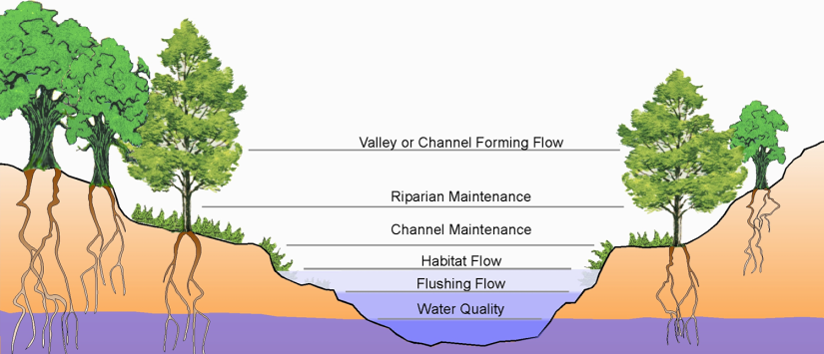

***Figure X.*** *Natural river systems are built and maintained by different magnitudes of discharge occurring over time and space. All flows (parts of the hydrograph are essential to the ecological functioning of the river system (Hill et al. . 1999, Terush et al. 2000)*

Groundwater occurs almost everywhere beneath the land surface (Alley et al. 1999). It’s widespread, and that is why it is so often used as a source of water. In Minnesota, approximately 75% of the population is served by groundwater. Groundwater is maintained by: 1) areal recharge from precipitation that percolates through the unsaturated zone to the water table, and 2) from losses of water from streams, lakes and wetlands. Changes in the runoff reaching the stream are likely to impact flows reaching groundwater aquifers, by effectively decreasing the water that percolates to the water table.

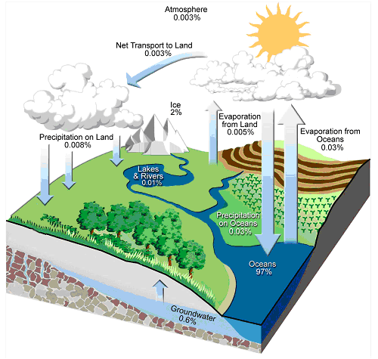

***Figure 55.*** *Graphical depiction of the hydrologic cycle, with relative values for each source. Groundwater and surface water sources of freshwater are those most used by humans. Dependence on these limited sources creates vulnerability if they become impaired in quality or quantity. (Adapted from Schlesinger 1991; Annear et al. 2004).*

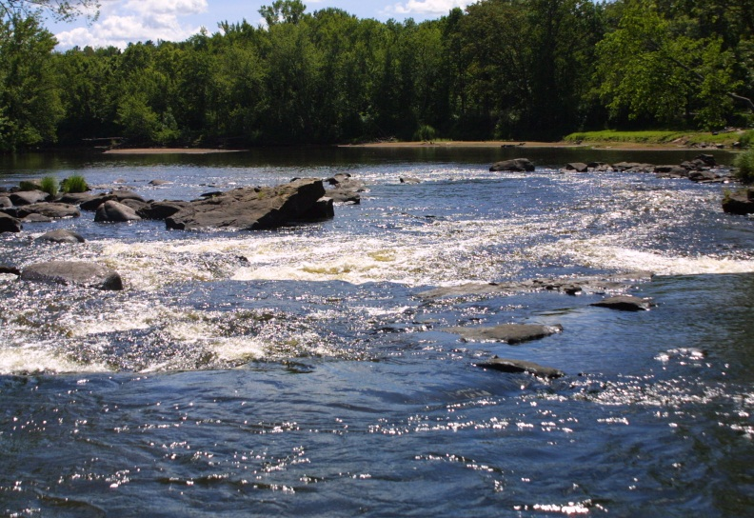

***Figure 56.*** *Rivers contain a tiny fraction of the world’s freshwaters, yet they are a vital component of the hydrologic cycle and landscape.*

*Interactions between groundwater and surface waters*

Groundwater is commonly an important source of surface water for use (Winter et al. 1998, Alley et al. 1999). While the amount of contribution of groundwater is variable from one stream to another, hydrologists estimate that average contribution is somewhere between 40 and 50 % in small and medium-sized streams. Groundwater also is a major source of water to lakes and wetlands. In terms of total freshwater available on the planet, about 75% is estimated to be stored in polar ice and glaciers and about 25% is estimated to be stored in groundwater (Alley et al. 1999).

*Recharge*

Critical to understanding groundwater-surface water interactions is an understanding of the exchange of water between these two systems. Under pre-development (before *any* groundwater pumping) conditions, the groundwater system is in long-term equilibrium. Ground water and surface water exchange water and chemical constituents depending on levels and conditions (e.g., climate) in these systems. Averaged over some period of time, the amount of water entering or recharging the groundwater system is approximately equal to the amount of water leaving or discharging from the system (Alley et al. 1999, Figure 7, (A)). The water leaving the groundwater system is discharged to streams and rivers and is called base flow. Humans change the natural or predevelopment flow system by withdrawing (pumping) water for use, changing recharge patterns by irrigation and urban development, changing the type of vegetation, and other activities. Focusing our attention on the effects of withdrawing groundwater, we can conclude that the source of water for pumpage must be supplied by (1) more water entering the ground-water system (increased recharge), (2) less water leaving the system (decreased discharge), (3) removal of water that was stored in the system, or some

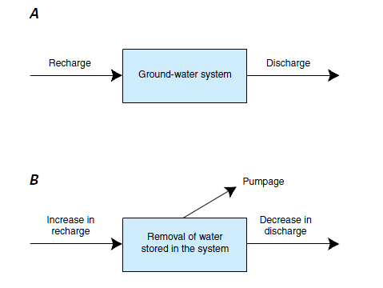

***Figure 56.*** *Water budgets for a groundwater system,, under pre-development and development conditions. (A) Pre-development: inflow equals outflow. (B) Under development (pumping), there are changes in flow. The sources of water for the pumpage are changes in recharge, discharge, and the amount of water stored. The initial predevelopment values do not directly enter the budget calculation. from Alley et al. (1999)).*



***Figure 55.*** *The principle source of water to a well can*

*change with time from groundwater storage to*

*capture of streamflow. (from Winter 1et al. 1998).*

combination of these three (Alley et al. 1999) . The water used must come from somewhere; a change in flows and from the removal of water stored in the pre-development groundwater system ( Theis 1940, Lohman 1972).

USGS latest publication on recharge rates in Minnesota

**B. Integrating Principles into a Management Approach**

Thresholds versus management prescriptions. Threshold is the line; management is the way we protect ourselves from crossing the line.

To begin to integrate the above principles into a management approach which is scientifically valid and politically and administratively feasible and lasting, several elements are necessary:

**1)** Establish a Sustainable Diversion Limit (SDL); placing a limit on the total volume appropriated from a water source in some defined space (e.g. watershed, or aquifer),

1. The SDL, total volume limit, protects larger-scale, long-term processes that are needed but when reduced may only reveal itself as a long-term trend;

**2)** Establish a Protected Flow (PF); which further limits appropriations during low flows or water levels;

1. The limitations during low flows or low levels protect resources that are in immediate danger (e.g., poor water quality effecting human health or creating fish kills, or low numbers of endangered or prized species in the following years).
2. Codify an adaptive management approach;
   1. Water systems and their connected resources are complex
   2. Our knowledge of these systems and related resources is incomplete.
   3. Adaptive management (learning as we manage, managing as we learn) must be instituted, formally, as the rationale approach to managing these systems and their resources.

Each of these elements are considered critical to translate the principles to a water management process, in a way that recognizes the realities of our science, our institutions, and changing social values. We briefly discuss each of these elements, and the supporting science, below.

***1) Limiting Total Water Withdrawals with the Sustainable Diversion Limit (SDL)***

Precedence for capping water use exists in surface water (lake withdrawals are currently capped at ½ acre-foot of total lake acreage) and ground water management. Expanding current management by establishing a cap on total surface water use for rivers within a given system (watershed) is designed to maintain the shape of the hydrograph even in the presence of high future demand. This recommendation is based on the principle that water management should be designed to anticipate unforeseen events and work in the event of increased future demand for water. Protecting high flows, ensures important functions such as sediment transport, habitat formation, and maintenance of riparian and river valley systems. All flows experienced throughout the hydrograph, including large flood flows, maintain the channel shape. The bankfull discharge, the flow that fills the channel to near the floodplain, is described as the dominant channel forming flow (Dunne and Leopold, 1978). These aspects of the hydrograph are protected through an approach which limits the amount of water that can be withdrawn at any point in time.

*Recommendation for a Sustainable Diversion Limit (SDL)*

To identify an SDL, we must determine when cumulative withdrawals will likely cause an adverse resource impact (ADI). Assessing the impact requires 1) building one or more relationships between the potential stressor (discharge as a result of streamflow depletion) and a variable of ecological importance, and 2) identifying the threshold or point at which an adverse impact is likely to exceed sustainability.

Information is available on two environmental variables that meet the above requirements for assessment; 1) the response of species richness to changes in discharge, and 2) the response of habitat to changes in discharge for various species and their life-stages. The use of the two flow ecology curves are built on the following fundamental concepts of ecology;

1. Biological diversity is critical to ecosystem health and sustainability (Dudgeon et al. 2006, Rapport et al. 1998, Loreau et al. 2001). Biological diversity includes two components: richness and species abundances (Noss 1990, Magurran 2004)
2. Selection for or persistence in a particular habitat is directly related to survival and reproduction, which determines fitness (Hutchinson 1957, Southwood 1977).
3. Habitat is a critical factor in determining a species distribution and abundance (Hanski 1982, Kolasa and Strayer 1988, Tokeshi 1993, Venier and Fahrig 1996, Gaston et al. 2000, VanDerWal et al. 2009).
4. Flow is the ultimate driver of river size, shape and physical habitat that in-turn is a major determinant of the fish occurrence, abundance and diversity (Leonard and Orth 1988, Bunn and Arthington 2002, Xenopoulos et al. 2005).

Median August discharge was chosen as the index flow from which to quantify the ecological response. Five factors lead to the use of median August discharge as the index flow; 1) water use is greatest during the summer months, 2) summer low flows are considered critical to populations of aquatic species (Poff et al. 1997, Power et al. 1999, Bradford and Heinonen 2008), 3) August discharge is used as the index flow in the Michigan water withdrawal assessment tool (Hamilton and Seelbach 2010) providing a practical example, 4) by setting total allocation limits based on the most sensitive and intensive water use season there will likely be less risk of unintended negative impacts on other life-stages or hydrologic and geoprocesses, and, 5) empirical evidence of the association between August discharge and both ecological measures (i.e., richness and habitat), discussed below in more detail.

*Flow Ecology Response Curve (Richness).*

Make sure main message is clear: loss of species = loss of integrity (community) and function

Species richness at the local scale is not only an indicator of ecosystem stress (Rapport et al. 1985) but also influences ecosystem processes (Loreau et al. 2001, Loreau et al. 2003) and is an important component of monitoring for ecosystem health (Pereira and Cooper 2006). No single factor regulates communities including richness (Zalewski and Naiman 1985, Levin 1992). However, the factor most often correlated to diversity of fish in rivers is stream size (e.g. channel width, link number, drainage area, mean annual discharge; Grenouillet et al. 2004, Livingstone et al. 1982, Hugueny 1989, Oberdorff et al. 1995, Oberdorff et al. 1997, Guégan et al. 1998, Cumming 2004, Xenopoulos et al. 2005). This relationship is analogous to the species-area curve well studied in the terrestrial literature (Rosenzweig 1995). In fact, Xenopoulos and Lodge (2006) forecast species lost with reductions in discharge.

A model for predicting the response of fish species richness to changes in discharge was developed for Minnesota. Due to the influence of sampling effort and number of individuals sampled, species richness was estimated instead of using the observed as recommended by Gotelli and Colwell (2001) and Magurran (2004). Fish species richness was estimated at the local scale (i.e., alpha diversity) using the nonparametric abundance based estimate of Chao (1987) with the R package vegan (Oksanen et al. 2013). Fish samples and environmental data were obtained from the Minnesota Pollution Control Agencies streams database. From the database only sites sampled June through October and after 1995 were included in the analysis resulting in 797 sites (Figure 1). Sites were located in each of the major basins of Minnesota (Hudson Bay, Great Lakes, and Mississippi River).

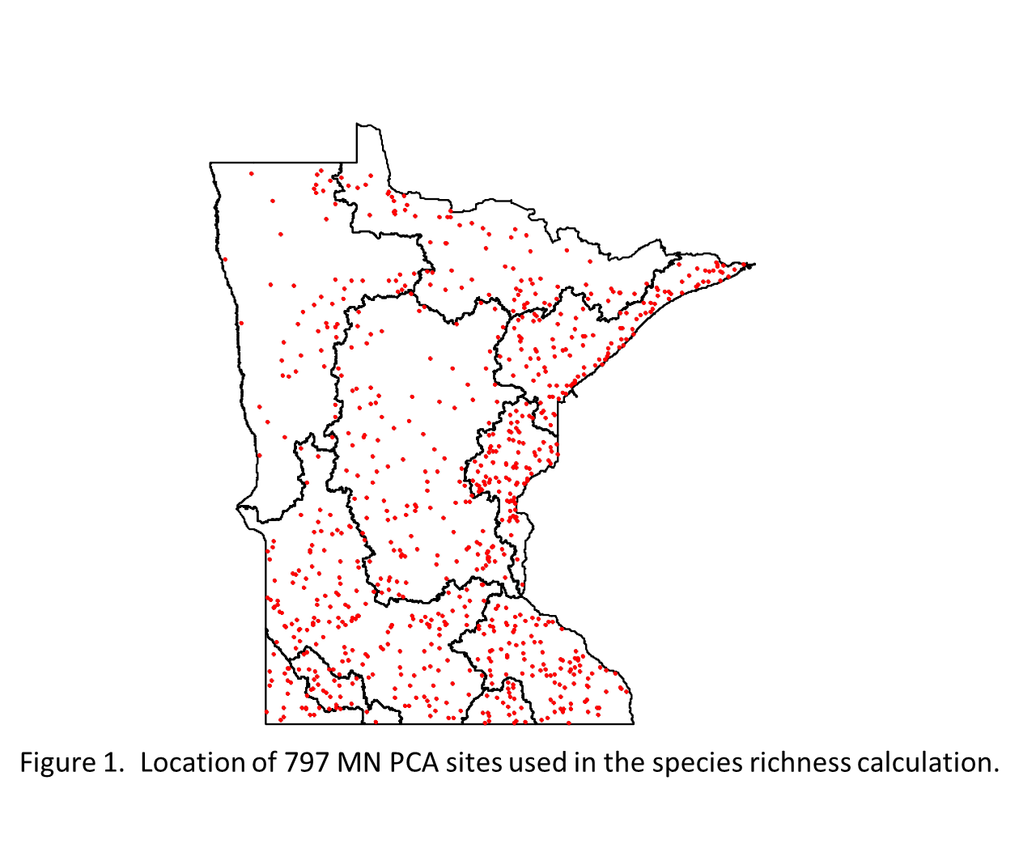

Stream gaging information was not available at the biological sampling sites, so mean August discharge values were estimated using a generalized additive model (Wood 2006). Data were collected from 54 stream gages located in and near Minnesota and for the years 1986 through 2007 (Figure 1). The model to estimate mean August discharge was fit using a smoothed function of the geographic coordinates (universal transverse mercator system) and a smoothed function of drainage area. Mean August discharge was used as a predictor instead of the median because the number of years used in the calculation was limited (12 gages included less than 20 years of data while 44 included 22 years of data). However, the mean and median August discharge for the 54 gages were highly correlated (r=0.97) with the median averaging 63% of the mean. Drainage area ranged from 83 to 6140 square miles with a mean of 1592. Observed mean August discharge ranged from 4 to 1938 cfs and averaged 364 cfs. The model accurately estimates the mean August discharge with 90.3% of the deviance explained and an adjusted deviance explained of 89.5 (Figure 1). The residual standard error is 3.02 in the transformed units (square root of discharge) and the mean and median absolute percent error in the original scale is 46.4 and 29.3%, respectively. The model overestimates the discharge for the Knife River (north shore of Lake Superior) resulting in the difference in mean and median error. By using only drainage area and geographic location the model can be used at ungaged sites in Minnesota.

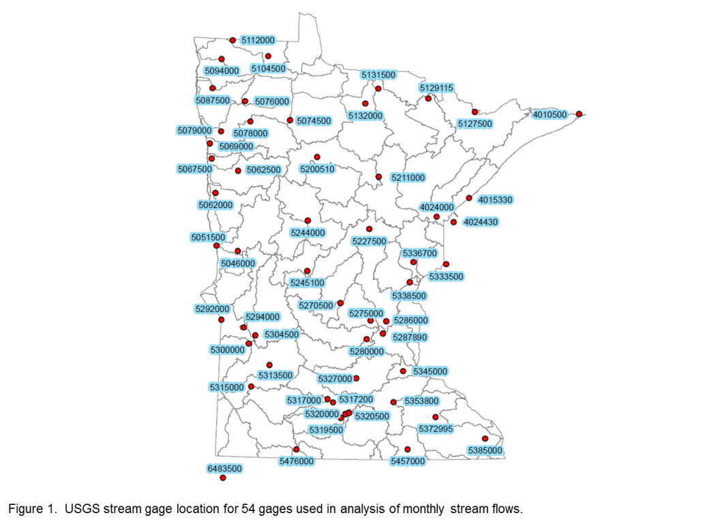

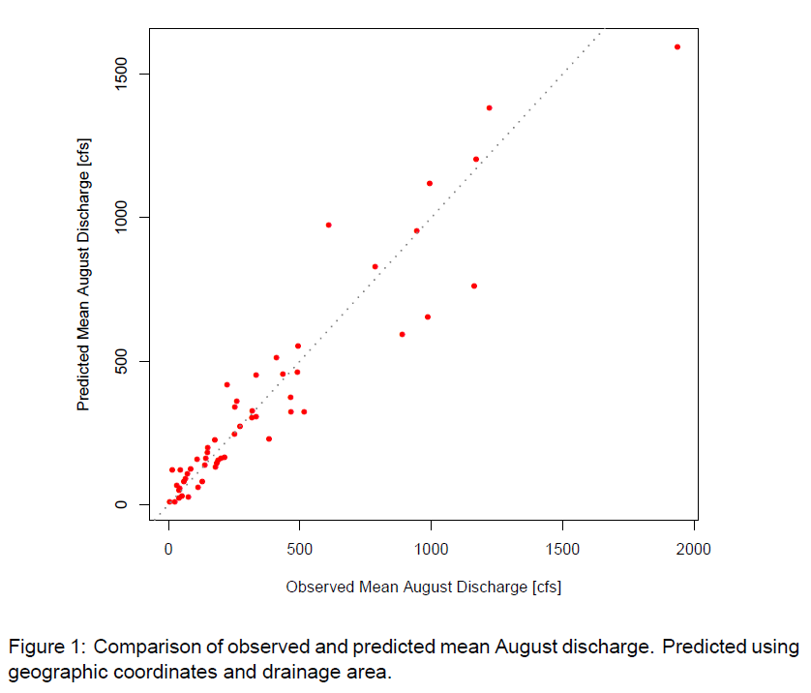

A fish species richness model was developed using August discharge (maugq [cfs]: estimated from the equation using drainage area and location), sampling effort (number of individual fish sampled: samnumall [number]), geographic location (universal transverse Mercator: utmx and utmy [m]), and physical conditions (dominant substrate size: domsub [1=bedrock, 2=rubble, 3=rubble, 4=gravel, 5=sand, 6=silt, 7=clay, 8=detritus, 9=other], average width of station: avgw [m], Shannon-Weaver diversity index of percent of riffle, pool, run). To capture their nonlinear relationship to species richness; geographic location, substrate, width, and discharge were transformed using restricted cubic splines (Harrell 2001). Cumulatively, 107 species were observed. Observed richness at individual sites ranges from 1 to 35 with an average of 11.6 species. A summary of observed and estimated richness and the predictor variables are provided in Table 1.

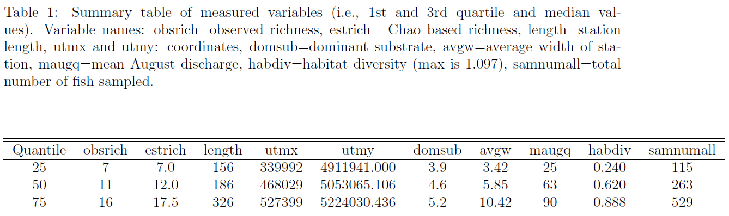

All analyses were performed using R (R Development Core Team 2013). A least squares regression equation using the above mentioned transformed and untransformed variables to estimate richness was fit using the rms package (Harrell 2014).

All terms (linear and nonlinear and interaction) in the model were significant. The model R2 was 60.6 with residual standard error of 4.88 and a mean and median absolute percent error 51.7 and 24.9%, respectively. The relationship between the individual variables and species richness and the overall test of association for the predictor (F-test) are shown in Figure 1-8. The display represents the effect of each predictor while holding the other variables at their median value. In addition for comparison between the predictors, the effect of each predictor on richness is displayed assuming a change from the 0.25 quantile to the 0.75 quantile while holding the other variables at their median value (Figure 1). The amount of variation in richness explained by discharge is similar to that found by Xenopoulos and Lodge (2006) for the Lower Ohio – Upper Mississippi and Southeastern United States drainages.

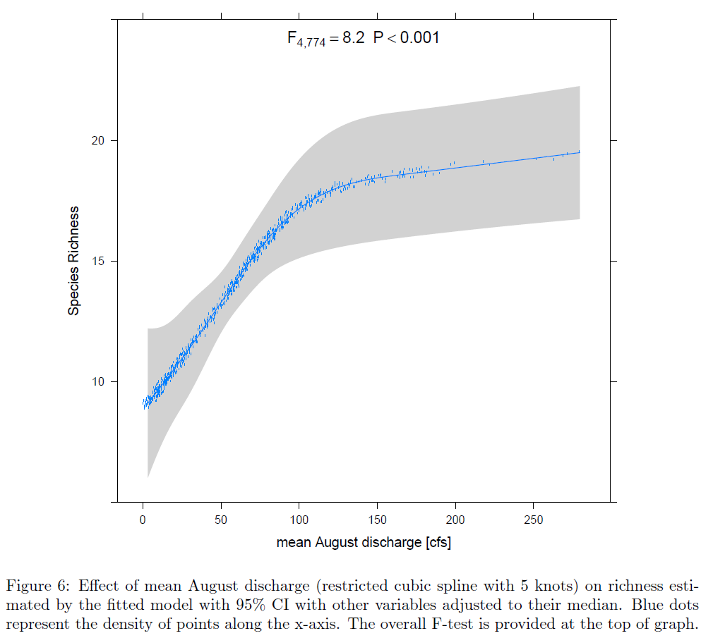

For water management the critical component of the fitted regression model is the association between August discharge and fish species richness. The significant and nonlinear relationship can be used to predict the change in richness with a change in discharge. The relationship suggests that species richness in larger streams (i.e., those with a mean August discharge of greater than 120 cfs) is less sensitive to changes in discharge than smaller streams (Figure 1). Figures 1 displays the expected impact to species richness (in numbers and percentage) with a decrease in discharge. For example, if a stream has a mean August discharge of 100 cfs and streamflow depletion results in a loss of 15 cfs or 15% of the flow, then an estimated one species is lost (estimated richness 17 and 16, respectively). So as to not underestimate the risk of streamflow depletion both a 50 and 90% mean confidence interval are provided.

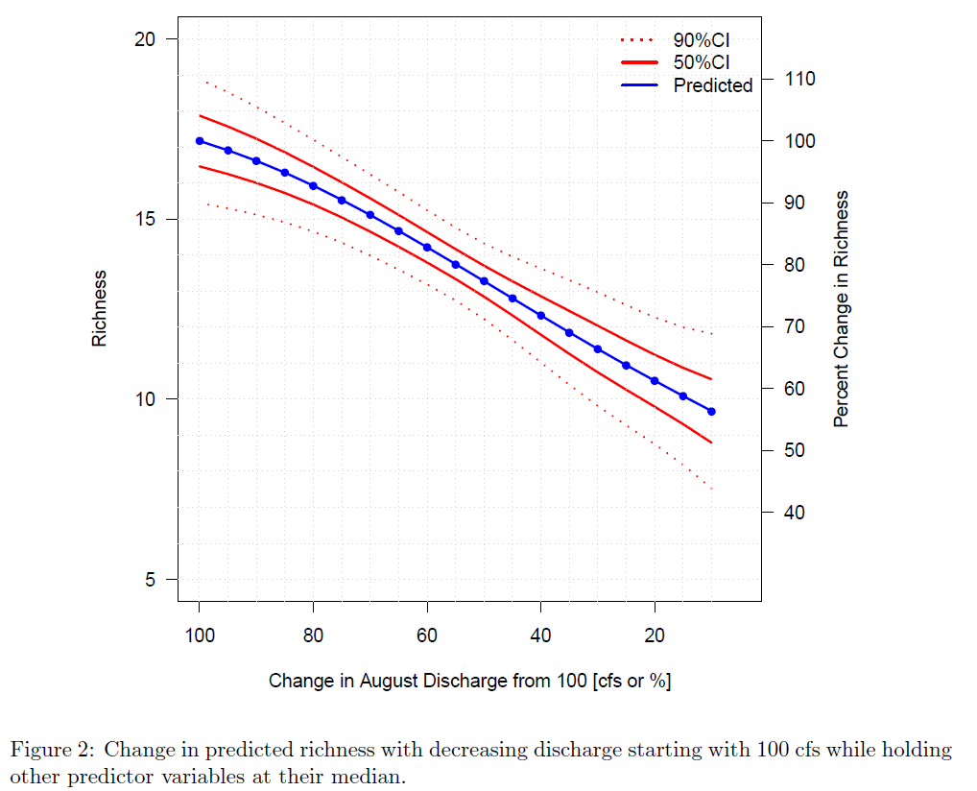

The richness-discharge association found in Minnesota is consistent with those found by Xenopoulus and Lodge (2006) in two large United States drainages. Their findings suggest that a 20% decrease in mean annual discharge will likely lead to a loss of 2 to 4 species in various drainages of the Lower Ohio-Upper Mississippi basin which represents about 2-3% of the species. Minnesota results suggest that for streams averaging 100 cfs in August a 20% loss in discharge will result in an average loss of 1.6 species representing 9% of the richness.

These results suggest that mean August discharge as an index flow to actively monitor and use as a protection standard is relevant to managing for sustainability because it is both relevant to biodiversity and is a critical period of time for off-stream users of waters. The results are also consistent with other findings. Figure 2 can be used to assess the change in species richness resulting from a decrease in discharge for streams that have a mean August discharge between 10 and 100 cfs, however, the Percent Change in Richness is based on the estimated richness at 100 cfs.

*Flow Ecology Response Curve (Habitat).*

As emphasized in the title of this report we are concerned with ecology which by definition is the distribution and abundance of organisms (Andrewartha and Birch 1954). In fact Andrewartha and Birch (1954) go on to state that ‘…distribution and abundance are but the obverse and reverse aspects of the same problem.’ The influence of habitat on the distribution and abundance of animals has been well discussed and documented (Brown 1984, Gaston et al. 2000) including for stream fish species (Hubert and Rahel 1989, Jowett et al. 1996).

Flow recommendations for the biological component are based on aquatic habitat discharge relationships for species representing six habitat-preference guilds (Aadland, 1993). Managing habitat for the entire aquatic community instead of a single species will help to promote long-term sustainability of the ecosystem (Osmundson et al., 2002; Rosenfeld, 2003). Local evidence of the relationship between habitat conditions and abundance is provided for multiple aquatic organisms with data collected from 38 sites by the MN DNR Stream Habitat Program (SHP). Data collection techniques are described in (Aadland and Kuitunen 2006). Secondly, the response of habitat to changes in streamflow is presented for 7 sites in Minnesota where detailed hydraulic modelling was available. The hydraulic modeling and estimation of habitat followed the instream flow incremental methodology (Bovee 1982) and used the physical habitat simulation models (Milhouse et al. 1989). Habitat modeling in this system relies on microhabitat preference curves, which have been developed for stream fish and mussel species in Minnesota (Aadland and Kuitunen 2006). The second relationship, habitat versus flow, is the fish population metric used to assess the impact of streamflow depletion.

The relationship between habitat and abundance is presented for four species life-stages (Figure 1). Following the method of Oliver et al. (2012), first a habitat model was developed to estimate the probability of occurrence, then in a second step the probability of occurrence was used as an explanatory variable to estimate abundance. The resource selection function (Boyce and McDonald 1999) or each species was fitted using the logistic regression function available in the R (R Core Team 2013) package rms (Harrell 2014). The logistic habitat modeling though different than the preference curves developed in Aadland and Kuitunen (2006) used the same variable information including; depth, velocity, substrate size, and measures of cover. The results of the resource selection function, the probability of occurrence (a measure of habitat quality), was compared to abundance and a linear or non-linear 95th quantile regression (Cade and Noon 2003) was used to model the response of the extremes of abundance (95th quantile) to habitat conditions.

Each of the four resource selection functions (i.e., logistic model) were significant (Likelihood ratio test P<0.001) and provided excellent discrimination (Hosmer and Lemeshow 2000: area under the receiver operator curve = 0.88, 0.82, 0.88, and 0.91 for the following species life-stages respectively, BDDA, SHDA, BNTA, and BNTY). Although the response of abundance to habitat (measured as probability of occurrence) displays increasing variability and spread from zero to a maximum value (i.e., wedge shaped distribution), the upper extremes of the distribution exhibit a distinct increase with increasing habitat quality. In each graph of Figure 1, a quantile regression fit to the upper extremes (i.e., 95% quantile) indicates abundance significantly (P<0.001) increases with habitat quality. A wedge-shaped distribution of points in an abundance metric response to habitat quality graph is common in fish (Terrell et al. 1996, Dunham et al. 2002, Knight et al. 2013) and has been found and modeled using quantile regression in freshwater mussels (Allen and Vaughn 2010) and benthic macro-invertebrates (Milhouse and Bartholow 2006). This wedge or triangular shape is consistent with a complex system where multiple factors may limit (described as Liebig's law of the minimum in Dunham et al. 2002 and Knight et al. 2013) a population below the maximum or ceiling set by the physical habitat (Terrell et al. 1996, Cade et al. 1999). The four graphs in Figure 1 clearly show that habitat quality for a species controls the upper limit of abundance and that the species are part of a complex system where unmeasured factors at many sites influence abundance.

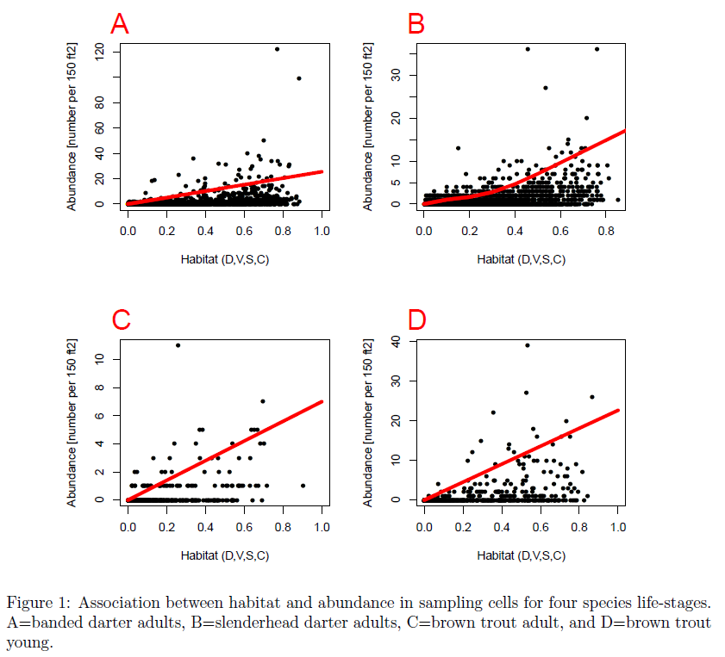

The response of habitat to discharge is presented for seven sites across Minnesota (Figures 1-7). Of the seven sites one is a trout stream (Straight River, unpublished hydraulic modeling data but location described in Aadland and Kuitunen 2006), two drain to the Red River (Red Lake River: site and modeling descriptions in Harvey et al. (1997), and Wild Rice River: site and modeling descriptions in Kuitunen et al. (1997)), two to the Minnesota River (Yellow Medicine River: site and modeling descriptions in Terry et al. (1997), and Pomme de Terre River: site and modeling descriptions in Terry et al. (1999)), one to the Missouri River (Rock River: site and modeling descriptions in Kuitunen (2001)) and one to the Mississippi River (St. Croix River: site and modeling descriptions in Johnson et al. (1998)).

At each site, the relationship between total weighted usable area, area weighted by the habitat suitability (Aadland and Kuitunen (2006), for various species life-stages and discharge was developed. Based on nearby streamflow records a habitat time series was developed for all available daily August discharge values and was considered the unaltered condition (i.e., no attempt was made to adjust flows for ongoing water withdrawals). Habitat time series based on daily flows were developed for ten additional discharge scenarios. The additional scenarios were based on levels of use in increments of 10% (ranging from 10% to 100% of the August median flow used) of the observed median daily August discharge but with an August 90% exceedance flow protection level. The habitat response for species in the Straight River (Figure 1) shows the response when no minimum flow level is protected in addition to the August 90% exceedance protection level. To summarize the response of habitat to streamflow depletion the median habitat value for each discharge scenario was calculated and then normalized to the maximum median habitat value. This is plotted as the Proportion of Habitat Remaining and ranges from 0 to 1. Multiple species life-stages (for both fish and mussels) are modelled at each site so that a diversity of responses can be assessed, but typically species that prefer shallower and faster water are most impacted by streamflow changes.

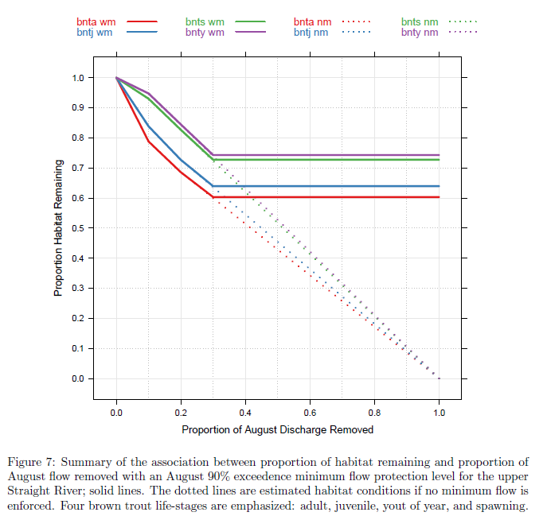

Typically but not in all cases the maximum value of habitat for a species life-stage occurs at the observed discharges. For each graph, three to four species responses are highlighted because their habitat conditions decreased at a faster rate in response to discharge decreases. Tables 1 and 2 further summarize the results. On average, the initial and second species to lose 15% of their habitat does so at 14 and 16%, respectively, of the August median flow removed. Examined in reverse, removing 15% of the August median flow on average decreases the Proportion of Habitat Remaining to 0.80 for the species experiencing the largest decline in habitat and the species experiencing the second largest decline averaged a decrease to 0.83 in Proportion of Habitat Remaining. Despite the wide range of physical and biological conditions in the rivers the results were consistent both for the numerical response of habitat (proportion of habitat remaining with a 15% use ranged from average 0.80 with a coefficient of variation of 12%) and in which habitat guild (Aadland 1993) the most sensitive species life-stage represented (6 of 7 species were from the raceway guild). Raceway habitat followed by fast riffle habitat tends to be more sensitive to flow reductions than pools and slow riffles (Harvey et al. 1997, Terry et al. 1997, Terry et al. 1999). The August median flow is selected as the standard because August is a biologically meaningful low flow month- protecting this month establishes a logical basis for protecting the entire hydrograph. In other words, it is unlikely that cumulative withdrawals beyond the threshold established for this month would frequently exceed the percentage guideline in other months.

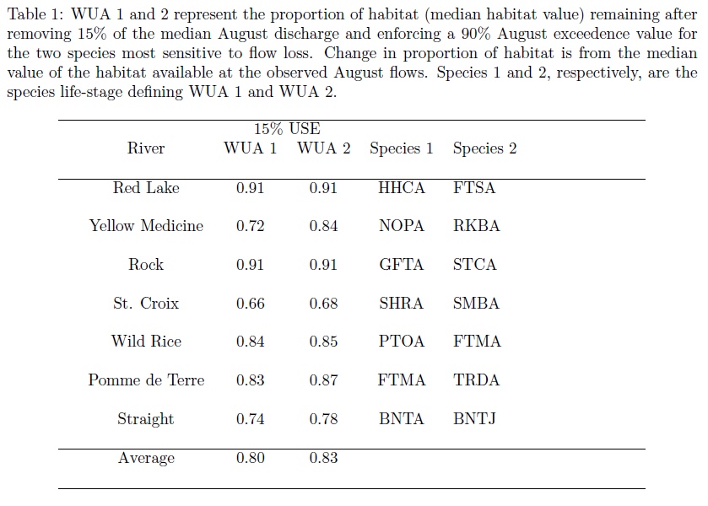

*Sustainable Diversion Limit (SDL) Recommendation*

Based on the findings above, a strong positive relationship exists between discharge (and its strongly correlated indicator, catchment area) and stream fish species richness (Xenopoulos and Lodge 2006). This relationship is analogous to the species-area curve well studied in the terrestrial literature. Additionally, a strong positive relationship exists between discharge and stream habitat. In effect, as flows are decreased, habitat declines, abundance will decline, and species will be lost**.** The response of both aquatic biodiversity (measured as fish species richness) and individual species (measured as habitat) to changes in streamflow have been well documented in the literature for streams of varying sizes and geographic locations. Results described here indicate a similar responses given the local physical and biological conditions of Minnesota. Additionally, the results across Minnesota are consistent despite the variability in the environment. Both the use of biodiversity and habitat meet the criteria discussed by Jorgensen et al. (2010) for good ecological indicators. From a practical and scientific standpoint, the response of biodiversity and habitat are relevant (biodiversity and habitat are clearly important to the long-term health of river systems and fundamental to ecology), scientifically justifiable across a broad geographic and physical scale (both relationships are well documented in the scientific literature globally and in Minnesota), and quantitative (both describe an incremental change in response with an incremental change in flow). **Given the results** **for Minnesota data, the literature related to this science, and the goal of sustainability, we recommend a SDL of 15% of the August median flow be applied.**

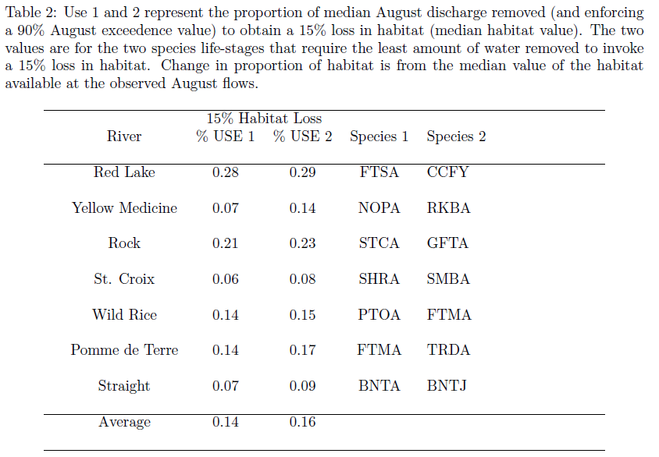

Main message should be clear: loss of water = loss of water = loss of habitat (1:1 or virtually so) = loss of community, loss of ecological integrity and function

***2) Protected Cutoff Level***

The habitat-based minimum flow would afford protection from increasing the frequency of direct impacts to aquatic populations from extreme flow events as well as provide adequate contaminant dilution (water quality). Species exhibit a preference for particular hydraulic conditions that are controlled by flow (Gorman and Karr, 1978; Moyle and Vondracek, 1985; Grossman and Freeman, 1987; Meffe and Sheldon, 1988; Bart Jr, 1989; Kessler et al., 1995).

Low flows in streams and rivers have long been recognized as drivers for aquatic and riparian ecosystems (Bradford and Heinonen 2008). Warmwater streams are extremely vulnerable to flow manipulations (Stalnaker 1981). Because the natural timing, magnitude, and frequency of streamflows dictate the evolutionary adaptations of many river biota (Bunn and Arthington 2002) and control many physical and chemical processes (Poff et al. 2010), anthropogenic alterations of streamflows may have profound effects on ecosystem structure and function. Decreases in discharge usually cause decreased water velocity, water depth, and wetted channel width; increased sedimentation; and changes in thermal regime and water chemistry. Invertebrate abundance increases or decreases in response to decreased flow, whereas invertebrate richness commonly decreases because habitat diversity decreases (Dewson et al. 2007). Research findings demonstrate that, across divergent natural and anthropogenic settings, the likelihood of biological impairment grows with increased reductions of maximum and minimum streamflow magnitudes (Carlisle et al. 2010). “Although drought acts as a sustained ‘ramp’ disturbance, impacts may be disproportionately severe when certain critical thresholds are exceeded. For example, ecological changes may be gradual while a riffle dries but cessation of flow causes abrupt loss of a specific habitat, alteration of physicochemical conditions in pools downstream, and fragmentation of the river ecosystem. Many ecological responses to drought within these habitats apparently depend on the timing and rapidity of hydrological transitions across these thresholds, exhibiting a ‘stepped’ response alternating between gradual change while a threshold is approached followed by a swift transition when a habitat disappears or is fragmented” (quoted from Boulton 2003).

To examine the hydrologic effects of water diversion on low flows in August, two management scenarios were compared to the natural flows in the Pomme de Terre River (Table X, Table X2).

|  |  |  |  |
| --- | --- | --- | --- |
| **Management Scenario** | **Number of Years with Zero August Flows**  **(% of total)** | **Number of Years with August Flow below 7Q10**  **(% of total)** | **Number of Years with August Flow below Q90**  **(% of total)** |
| Natural flows | 2  (2%) | 5  (6%) | 13  (16%) |
| Use: 10% of MABF No Protected Minimum | 9  (11%) | 11  (13%) | 18  (22%) |
| Use: 15% of MABF  No Protected Minimum | 13  (16%) | 13  (16%) | 21  (26%) |

**Table X**. Comparison of low flow incursion rates in August on the Pomme de Terre River, for 2 management options and the natural flows, over the past 82 years (1931-2015). The number of years that flows reached the 7Q10 (0.7 cfs - a water quality low flow limit), the Q90 exceedence value (7.6 cfs), and the number of zero flows are provided for each scenario. The median August baseflow (MABF) for this gage (05294000) at Appleton, MN is 47 cfs.

These data show a clear, growing impact; low flow instances are increased if water is withdrawn during drought conditions, and more so as additional water is used (Table X). For the Pomme de Terre River, the number of years with zero flows for natural conditions during the 82 year period of record was 2. This increased to 9 and 13 years under 10% of the MABF use scenario and 15% of the MABF use, respectively. The 7Q10 is a flow statistic used for identifying the volume of water needed to meet point discharge water quality thresholds. It can be used as a check for low flow prescriptions to ensure that water quality standards are not violated (Annear et al. 2004). The number of years below this value were increased by use, from 5 instances under natural conditions to 11 and 13 years for 10% of the MABF use and 15% of the MABF use, respectively. A similar, but more distinct pattern was found using the Q90 as a marker: in 13 years natural flows in August were less than the Q90, which was increased to 18 and 21 years by the 10% MABF use and the 15% MABF use, respectively.

Another important aspect of low flow conditions is the duration of the low flow periods. The longer the duration of extreme low flows, the greater the impact on the existing aquatic community. The duration of extreme low flows is also increased by water use (Table X2). In the Pomme de Terre River, zero flow days in August occurred during 27 days during the 82 year period of record (1931-2015). This was increased to182 days under water use set at the 10% of

|  |  |  |  |
| --- | --- | --- | --- |
| **Management Scenario** | **Number of August Days with Zero Flows**  **(% of total)** | **Number of August Days with Flow below 7Q10**  **(% of total)** | **Number of August Days with Flow below Q90**  **(% of total)** |
| Natural | 27  (1%) | 49  (2%) | 255  (10%) |
| Use: 10% of MABF  No Protected Minimum | 182  (7%) | 204  (8%) | 385  (15%) |
| Use: 15% of MABF  No Protected Minimum | 246  (10%) | 257  (10%) | 443  (17%) |

**Table X2**. Comparison of low flow incursion rates in August on the Pomme de Terre River, for 2 management options and the natural flows, over the past 82 years (1931-2015). The duration (number of days) that flows reached the 7Q10 (0.7 cfs - a water quality low flow limit), the Q90 exceedence value (7.6 cfs), and zero flows, are provided for each scenario. The median August baseflow (MABF) for this gage (05294000) at Appleton, MN is 47 cfs.

MABF level, and 246 days under water use at the 15% of MABF level. The 7Q10 flows during August were exceeded during 49 days under natural flows. This duration was increased to 204 days and 257 days at water use levels of 10% and 15% of the MABF, respectively. Similarly, the number of August days with flows below the Q90 (for August), were 255 under natural conditions, which was increased to 385 day under water use of 10% of the MABF, and 443 days under water use of 15% of the MABF.

Slide 33

Slide 35

Slide 36

Map of IFIM sites across state

Slide 37 (all spp by site - 9)

The evidence is overwhelmingly in favor of management strategies that include two elements to sustain water and the associated ecosystems for the long-term: limit the cumulative water use and recognize and enforce a flow cutoff for use during drought conditions. This conclusion is not novel: analysis of the tradeoffs between environmental flows and agricultural water security in California concluded that “strategies are particularly needed for drought-year water management to ensure adequate environmental flows while reducing human water allocations in an equitable manner.” (Grantham et al. 2014).

“Do droughts hurt fish? Yes. Drought, as an immediate, proximate stressor, clearly affects local populations by outright destruction of individuals as pools dry or water quality erodes. However, a better question may be how drought influences fishes on scales of space, time and organizational complexity (see Table 1). This broader view suggests that drought can influence evolution of species, local communities, ecosystems or fish faunas at a continental scale” (quoted from Matthews and Marsh-Matthews 2003).

loss of water=loss of habitat=loss of community=loss of ecological function and integrity

***3) Adaptive Environmental Assessment and Management: A Necessary Complement to Water Management***

Rivers are complex and dynamic systems. Scientists have an incomplete understanding of these complex systems, and thus our ability to predict change is limited. Because management of river corridor habitats has most often not resulted in sustained ecosystem benefits, a shift in perspective is occurring within the field of natural resource management. Traditional management approaches – focusing on one aspect or product – are not sufficient. We require approaches that take into account: 1) complex species interactions and interrelationships, 2) both abiotic and biotic factors, and, 3) the uncertainties inherent in complex, dynamic systems.

Despite substantial uncertainty, resource managers must still make decisions and implement policies. To integrate environmental understanding effectively within our economic and social systems, that are also dynamic, requires an adaptive approach. Adaptive Management is learning by doing. Within this approach, management actions, system modeling, data gathering, and decision-making all interact to maximize information gains and feedback, while providing enough flexibility to allow the changes which will increase management effectiveness and

efficiency (Holling 1978). Ongoing assessment and monitoring are key components of Adaptive Management. These assessments provide a detailed description of the current state and condition of the system, which serve as the basis for comparison with later conditions. The integrated analysis that is necessary in Adaptive Management increases the overall understanding of the system, and in turn, increases the accuracy of predicting how the system will respond. Consequently, Adaptive Environment Assessment and Management includes much more than just monitoring and trying alternative management actions. It involves the “application of systems techniques – e.g., computer modeling, mathematical analysis, optimization, utility analysis, and communication” (Holling 1978). It is a process to proceed in

the face of uncertainty, providing sound alternatives to “charging blindly ahead” or being “paralyzed by indecision”. Given the dynamic, complex, and often unpredictable nature of the economy, society, and the environment, adaptive assessment and management is a necessary component of a long-term management policy.

**Slide 41Slide 42**

**Slide 43**

**If greater than 1:1 loss encountered at 10% withdrawal, then examine streams for characteristic sensitive groupings, e.g. calcareous fens; adaptive management, slide 38**

**Cite ELOHA where it makes sense**

**Table 1**. *Phenomena related to fishes reported or predicted to be affected by drought, across increasing scales of organizational complexity (Matthews and Marsh-Matthews 2003).*

|  |
| --- |
| **Individuals**  Survivorship and mortality as a result of desiccation, lack of physiological tolerances  Energetic balance, reflected in reduced condition, growth, reproductive output  Reduced lifespan  Local movements and emigration  Microhabitat changes, with changes in food use or predator pressure  **Local populations**  Local extinction  Genetic bottlenecks  Hybridization  Intraspecific competition and density effects  Change in population size  Cohort failure  Population fragmentation  Changes in total biomass  **Local assemblages**  Changed assemblage composition  Changed emergent properties such as diversity, richness, evenness  Increased interspecific competition, crowding  Intensified predation  Changes in assemblage biomass  **Metapopulations**  Increased extinction rates, lowered rescue rates  Changed gene frequencies for ‘rescuers’  **Basin or regional faunas**  Geographic distributions  Basin-regional extinction  **Effects of fish in ecosystems**  Altered primary productivity and structure of algal communities  Changes in invertebrate assemblages or biomass  Changes in fish-mediated processing or transport of nutrients  and particulate organic matter  Bioengineering including disturbance of substrata  Altered rates of other ecosystem processes  **Evolutionary effects**  Changes in gene frequencies  Isolation and vicariance  Speciation and diversification  Physiological adaptations  Evolution of higher taxa  Faunal regionalization and continental faunal patterns |

**Glossary**

**Adverse Resource Impact**

**Ecological Threshold**

**Sustainable Management**

**Management Prescription**

**References**

Aadland, L. P. 1993. Stream habitat types: Their fish assemblages and relationship to

flow. *North American Journal of Fisheries Management* 13:790-806.

Aadland, L. P., C. M. Cook, M. T. Negus, H. G. Drewes, and C. S. Anderson. 1991. Microhabitat preferences of selected stream fishes and a community-oriented approach to instream flow assessments. Investigational Report No. 406. St. Paul: Minnesota Department of Natural Resources, Fisheries Section.

Acreman, M.C., and A.J.D. Ferguson. 2010. Environmental flows and European Water Framework Directive. Freshwater Biology 55:32-48.

Adams, J. B., G. C. Bate, T. D. Harrison, P. Huizinga, and others. 2002. A method to assess the freshwater inflow requirements of estuaries and application to the Mtata Estuary, South Africa. *Estuaries* 25 (6B):1382-1393

Adams, J. G., and M. W. Street. 1969. Notes on the spawning and embryological development of blue-back herring (*Alosa aestivalis* Mitchell) in the Altamaha River, Georgia. Contribution Series No. 16. Brunswick: Georgia Department of Natural Resources, Marine Development, Coastal Fisheries Division, and Game and Fish Commission.

Amoros, C., A. L. Roux, J. L. Reygrobellet, J. P. Bravard, and G. Pautou. 1987. A method for applied ecological studies of fluvial hydrosystems. *Regulated Rivers: Research and Management* 1:17-38.

Alley, W. M. , T.E. Reilly, and O.L. Franke 1999. Sustainability of ground-water resources. technical Report U.S. Geological Survey ircular 1186, U.S. Department of the Interior, U.S. Geological Survey.

Anderson, R. J., and D. K. MacKay. 1973. Preliminary study of the seasonal distribution of flow in the Mackenzie Delta, Northwest Territories. Pages 71-110 *in*  need editor’s name *Hydrologic Aspects of Northern Pipeline Development.* Task Force on Northern Oil Development. Quebec: Department of the Environment, Water Resources Branch (Report No. 73-3).

Annear, T. C., W. Hubert, D. Simpkins, and L. Hebdon. 2002. Behavioural and physiological response of trout to winter habitat in tailwaters in Wyoming, USA. *Hydrologic Processes* 16:915-922.

Annear, T. C., and J. M. Neuhold. 1983. Characterization of Yampa and Green River ecosystems: a systems approach to aquatic resource management. Pages 181-192 *in* V. D. Adams, and V. A. Lamarra, editors. *Aquatic Resources Management of the Colorado River Ecosystem*. Ann Arbor, MI: Ann Arbor Science.

Annear, T., I. Chisholm, H. Beecher, A. Locke, P. Aarrestad, C. Coomer, C. Estes, J. Hunt, R. Jacobson, G. Jobsis, J. Kauffman, J. Marshall, K. Mayes, G. Smith, R. Wentworth, and C. Stalnaker. 2004. Instream Flows for Riverine Resource Stewardship - Revised Edition. Instream Flow Council, Cheyenne, WY.

Arden, R. S., and T. E. Wigle. 1972. Dynamics of ice formation in the upper Niagara River. *Proceedings of the International Symposium on the role of snow and ice in hydrology: Symposium on measurement and forecasting*. WMO-4: Measurement and forecasting specific to river and lake ice, UNESCO/WMO/IAHS, Banff, Canada, 2: 1296-1313

Armour, C. L. 1991. Guidance for evaluating and recommending temperature regimes to protect fish. Instream Flow Information Paper No. 28. Fort Collins, CO: U.S. Fish and Wildlife Service, National Ecology Research Center (Biological Report 90 [22]).

Auble, G. T., J. M. Friedman, and M. L. Scott. 1994. Relating riparian vegetation to present and future streamflows. *Ecological Applications* 4(3):544-554.

Barber, L. B., G. K. Brown, and S. D. Zaugg. 2000. Potential endocrine disrupting organic chemicals in treated municipal wastewater and river water. Pages 97-123 *in* L. H. Keith, T. L. Jones-Lepp, and L. L. Needham, editors. Analysis of Environmental Endocrine Disruptors. Reprinted from American Chemical Society, Symposium Series 747. Denver: American Chemical Society.

Barrineau, C. E. 2003.Evaluation of the design of instream habitat structures relative to winter trout habitat in a Wyoming foothills stream. Master’s thesis. Laramie: University of Wyoming, Department of Zoology and Physiology.

Bartholow, J. M. and T. J. Waddle. 1986. Introduction to stream network habitat analysis. Instream Flow Information Paper No. 22. Washington, DC: U.S. Fish and Wildlife Service (Biological Report 86[8]). 242 pp.

Bauersfeld, K. 1978a. Stranding of juvenile salmon by flow reductions at Mayfield Dam on the Cowlitz River, 1976. Technical Report 36. Olympia: Washington Department of Fisheries.

Bauersfeld, K. 1978b. The effect of daily flow fluctuations on spawning fall chinook in the Columbia River. Technical Report 38. Olympia: Washington Department of Fisheries.

Baxter, R. M. 1977. Environmental effects of dams and impoundments. *Annual Review of Ecological Systems* 8:255-283.

Bayha, K., and C. Koski, editors. 1974. *Anatomy of a River*. Vancouver, WA: Pacific Northwest River Basins Commission.

Becker, C. D., D. H. Fickeisen, and J. C. Montgomery. 1981. Assessment of impacts from water level fluctuations on fish in the Hanford Reach, Columbia River. Richland, WA: Pacific Northwest Laboratory (PNL-3813).

Becker, G. C. 1983. Fishes of Wisconsin. Madison: University of Wisconsin Press.

Beecher, H. A.., J. P. Carleton, and T. H. Johnson. 1995. Utility of depth and velocity preferences for predicting steelhead parr distribution at different flows. *Transactions of the American Fisheries Society* 124:935‑938.

Beecher, H. A., W. C. Hixson, and T.S. Hopkins. 1973. Fishes of a Florida oxbow lake and its parent river. *Florida Scientist* 40 (2):140‑148.

Beecher, H. A., T. H. Johnson, and J. P. Carleton. 1993. Predicting microdistributions of steelhead parr from depth and velocity criteria: Test of an assumption of the instream flow incremental methodology. *Canadian Journal of Fisheries and Aquatic Sciences* 50(11):2380‑2387.

Beltaos, S. 1995. *River Ice Jams*. Highlands Ranch, CO: Water Resources Publications, LLC. 372 pp.

Benson, N. G. 1981. The freshwater inflow to estuaries issue. *Fisheries*  6 (5): 8-10.

Bisson, P. A., K. Sullivan, and J. L. Nielsen. 1988. Channel hydraulics, habitat use, and body form of juvenile coho salmon, steelhead, and cutthroat trout in streams. *Transactions of the American Fisheries Society* 117 (3): 262-273

Black, P. E. 1972. Hydrograph responses to geomorphic model watershed characteristics and precipitation variables. *Journal of Hydrology* 17:309.

Booth, D. B., D. Hartley, and R. Jackson. 2003. Forest cover, impervious surface area and the mitigation of stormwater impacts. *Journal of the American Water Resources Association* 38(4):835-845.

Boulton, A.J. 2003. Parallels and contrasts in the effects of drought on stream macroinvertebrate assemblages. Freshwater Biology 48: 1173-1185.

Bovee, K. D. 1974. The determination, assessment, and design of instream value studies for the northern Great Plains region. Master’s thesis. Columbia: University of Missouri.

Bovee, K. D. 1982. A guide to stream habitat analysis using the Instream Flow Incremental Methodology. Instream Flow Information Paper No. 12. Washington, DC: U.S. Fish and Wildlife Service (FWS/OBS‑82/26).

Bovee, K. D., B. L. Lamb, J. M. Bartholow, C. D. Stalnaker, J. Taylor, and J. Henriksen. 1998. Stream habitat analysis using the Instream Flow Incremental Methodology. Fort Collins, CO: U.S. Geological Survey, Biological Resources Division (Information and Technical Report USGS/BRD-1998-0004). 131 pp.

Bovee, K. D., and R. T. Milhous. 1978. Hydraulic simulation in instream flow studies: Theory and technique. Instream Flow Information Paper No. 5. Washington, DC: U.S. Fish and Wildlife Service (FWS/OBS-78/33).

Bovee, K. D., and M. L. Scott. 2002. Implications of flood pulse restoration for *populus* regeneration on the upper Missouri River. *River Research and Applications* 18:287-298

Bradford, M.J. and J.S. Heinonen. 2008. Flow flows, instream flow needs and fish ecology in small streams. Canadian Water Resources Journal 33(2):165-180.

Brinson, N. M., B. L. Swift, R. C. Plantico, and J. S. Barclay. 1981. Riparian ecosystems: Their ecology and status. Kearneysville, WV: U.S. Fish and Wildlife Service (FWS/OBS-81/17).

Brock, T. D. 1967. Relationship between standing crop and primary productivity along a hot spring thermal gradient. *Ecology* 48: 566-571.

Brown, D. E., C. J. Lowe, and F. Hausler. 1977. Southwestern riparian communities: Their biotic importance and management in Arizona. Pages 201-211 *in* R. R. Johnson and D. A. Jones, technical coordinators. *Importance, Preservation and Management of Riparian Habitat: Proceedings of a Symposium*, July 9, 1977, Tucson, AZ. Fort Collins, CO: U.S. Department of Agriculture, Rocky Mountain Forest and Range Experiment Station (General Technical Report RM‑43).

Brown, R. S, and W. C. Mackay. 1995. Fall and winter movements and habitat use by

cutthroat trout in the Ram River, Alberta. *Transactions of the American Fisheries Society* 124:873-885.

Brown, R. S., S. S. Stanislawski, and W. C. Mackay. 1994. Effects of frazil ice on fish. Page*s* 261-278 *in* T. D. Prowse, editor. *Proceedings of the Workshop on the Environmental Aspects of River Ice,* Saskatoon, Sask., 18-20 August 1993. NHRI Symposium Series No.12. Saskatoon, Sask: National Hydrology Research Institute.

Bunn, S.E. and A.H. Arthington. 2002. Basic principles and ecological consequences of altered flow regimes for aquatic biodiversity. Environmental Management 30:492-507.

Calow, P., and G. E. Petts. 1992. *The Rivers Handbook: Hydrological and Ecological Principles.* Volume 1. Boston: Blackwell Scientific Publications. 526 pp.

Calow, P., and G. E. Petts. 1994. The Rivers Handbook: Hydrological and Ecological Principles. Volume 2. Boston: Blackwell Scientific Publications. 523 pp.

Campbell, K. L., S. Kumar, and H. P. Johnson. 1872. Stream straightening effects on flood-runoff characteristics. *Transactions of the American Society of Agricultural Engineers* 15:94-98.

Carlisle, D.M., D.M. Wolock, and M.R. Meador. 2010. Alteration of streamflow magnitudes and potential ecological consequences: a multiregional assessment. Frontiers in Ecology and the Environment 9 (5): 264270. Doi:10.1890/100053

Castleberry, D. T., J. J. Cech, Jr., D. C. Erman, D. Hankin, and others. 1996. Uncertainty and Instream Flow Standards. *Fisheries* 2(8):20-21.

Chapin, D. M., R. L. Beschta, and H. W. Shen. 2002. Relationship between flood frequencies and riparian plant communities in the upper Klamath Basin, Oregon. *Journal of the American Water Resources Association.* 38: 603-617.

Chauvet, E., and H. Décamps. 1989. Lateral interactions in a fluvial landscape: The River Garonne, France. Journal of the North American Benthological Society 8(1):9-17.

Colborn, T. and C. Clement, editors. 1992. *Chemically-induced Alterations in Sexual and Functional Development: The Wild/Human Connection*. Princeton, NJ: Princeton Scientific, Princeton.

Colborn, T. and K. Thayer. 2000. *Aquatic ecosystems: harbingers of endocrine disruption. Ecological Applications* 10(4):949-957.

Colborn, T., F. S., Vom Saal, and A. M. Soto. 1993. *Developmental effects of endocrine disrupting chemicals in wildlife and humans*. Environmental Health Perspectives 101:378-384.

Collinson, J. D. 1971. Some effects of ice on a riverbed. *Journal of Sedimentary Petrology* 41(2):557-564.

Conner, W. H., and J. W. Day. 1976. Productivity and composition of a bald cypress-water tupelo site and a bottomland hardwood site in a Louisiana swamp. *American Journal of Botany* 63:1354-1364.

Copeland, B. J. 1966. Effects of decreased river flow on estuarine ecology. *Journal of Water Pollution Control Federation* 38(11):1831-1839.

Corning, R. V. 1970. Water fluctuation: A detrimental influence on trout streams. *Proceedings of the Twenty-Third Annual Conference of the Southeastern Association of Game and Fish Commissioners* 23:431-454

Covich, A. P., W. D. Shepard, E. A. Bergey, and C. S. Carpenter. 1978. Effects of fluctuating flow rates and water levels on chironomids: Direct and indirect alterations of habitat stability. Pages 141-155 *in* J. H. Thorp and J. W.Gibbons, editors. *Energy and Environmental Stress in Aquatic Systems.* Oak Ridge, TN: U.S. Department of Energy, Technical Information Center.

Crance J. H. 1988. Relationships between palustrine wetlands of forested riparian floodplains and fishery resources: a review. Washington DC: U.S. Fish Wildlife Service (Biol. Rep. 88[32]) 27 pp.

Crisp, D. T. 1987. Thermal “resetting” of streams by reservoir releases with special reference to effects on salmonid fishes. Pages 163-182 *in* J. F. Craig, and J. B. Kemper, editors. *Regulated Streams: Advances in Ecology*. New York: Plenum Press.

Cross, R. D., and D. L. Williams, editors. 1981*.*  *Proceedings of the National Symposium on Freshwater Inflow to Estuaries.* Volume 2. Washington, DC: U.S. Fish and Wildlife Service (FWS/OBS-81-04).

Cummins, K. W. 1980. The natural stream ecosystem. Pages 7-24 *in* J. V. Ward and J. A. Stanford, editors. *The Ecology of Regulated Streams*. New York: Plenum Press.

Cushman, R. M. 1985. Review of ecological effects of rapidly varying flows downstream from hydroelectric facilities. *North American Journal of Fisheries Management* 5:330-339.

Davis, J. C. 1975. Minimal dissolved oxygen requirement of aquatic life with emphasis on Canadian species: A review. *Journal of the Fisheries Research Board of Canada* 32(12):2295-2332.

Day, J. W., Jr., T. J. Butler, and U. H. Conner. 1977. Production and nutrient export studies in a cypress swamp and lake system in Louisiana. Pages 255-269 *in* M. Wiley, editor. *Estuarine Processes*. Volume 2. New York: Academic Press.

Decamps, H., J. Capblanq, H. Casanova, and J. M. Tourrenq. 1979. Hydrobiology of some regulated rivers in the southwest of France. Pages 273-288 *in* J. V. Ward, and J. A. Stanford, editors. The Ecology of Regulated Streams. New York: Plenum Press.

Dewson, Z.S. A.B.W. James, and R.G. Death. 2007. A review of the consequences of decreased flow for Instream habitat and macroinvertebrates. Journal of the North American Benthological Society 26(3):401-415.

Doering, P. H., R. H. Chamberlain, and D. E. Haunert. 2002. Using submerged aquatic vegetation to establish minimum and maximum freshwater inflows to the Caloosahatchie estuary, Florida. *Estuaries* 25(6B):1343-1354.

Dunne, T., and L. B. Leopold. 1978. Water in Environmental Planning. New York: W. H. Freeman and Company. 818 pp.

Dynesius, M., and C. Nilsson. 1994. Fragmentation and flow regulation of river systems in the northern third of the world. *Science* 266(4):753- 762.

Evans, D. H. 1997. *The Physiology of Fishes*. Boca Raton, FL: CRC Press.

Everest, F. H., R. L. Beschta, J. C. Scrivener, K. V. Koski, and others. 1987. Fine sediment and salmonid production: A paradox. Pages 98-142 *in* E. O. Salo, and T. W. Cundy, editors. Streamside Management: Forestry and Fishery Interactions. Contribution No. 57. Seattle: University of Washington, Institute of Forest Resources.

Ewing, K. L. 1978. Riparian ecosystems: Conservation of their unique characteristics. Need pages *In* R. R. Johnson and J. F. McCormack, editors. Strategies for protection and management of floodplain wetlands and other riparian ecosystems. Washington, DC: U.S. Forest Service (General Technical Report WO-12).

Extence, C. A. 1981. The effect of drought on benthic invertebrate communities in a lowland river. Hydrobiologia 83:217-224.

Fisher, S. G., and A. Lavoy. 1972. Differences in littoral fauna due to fluctuating water levels below a hydroelectric dam. *Journal of the Fisheries Research Board of Canada.*  29:1472-1476.

Flannery, M. S., E. B. Peebles, and R. T. Montgomery. 2002. A percent-of-flow approach for managing reductions of freshwater inflows from unimpounded rivers to southwest Florida estuaries. *Estuaries* 25 (6B): 1318-1332.

Folmar, L. C., N. D. Denslow, V. Rao, M. Chow, and others. 1996. Vitellogenin induction and reduced serum testosterone concentrations in feral male carp (Cyprinus carpio) captured near a major metropolitan sewage treatment plant. Environmental Health Perspectives 104(10):1096-1101.

Franklin, J. F., K. Cromack, and W. Dension. 1981. Ecological characteristics of old-growth Douglas-fir forests. Portland, OR: U.S. Forest Service Pacific Northwest Forest and Range Experiment Station (General Technical Report PNW-118).

Fraser, J. C. 1972. Regulated discharge and the stream environment. Pages 263-285 *in* R. T. Oglesby, C. A. Carlson, and J. A. McCann, editors. New York: Academic Press. *River Ecology and Man*.

Frissell, C. A. and D. Bayles. 1996. Ecosystem management and the conservation of aquatic biodiversity and ecological integrity. *Water Resources Bulletin* 32(2):229-240.

Frissell, C. A., W. J. Liss, C. E. Warren, and M. D. Hurley. 1986. A hierarchical framework for stream habitat classification: viewing streams in a watershed context. *Environmental Management* 10:199-214.

Fry, F.E.J. 1947. Effects of the environment on animal activity. Biological Series No. 55. Toronto: University of Toronto, Ontario Fisheries Research Laboratory. 62 pp.

Gallagher, S. P., and M. F. Gard. 1999. Relationship between chinook salmon (*Oncorhynchus tshawytscha*) redd densities and PHABSIM-predicted habitat in the Merced and Lower American rivers, California. *Canadian Journal of Fisheries and Aquatic Sciences* 56(4): 570-577.

Galli, J. 1990. Thermal impacts associated with urbanization and stormwater management best management practices. Metropolitan Washington Council of Governments. Maryland Deparmtent of Environment. Washington, D.C. 188 pp.

Gerking, S. D. 1950. Stability of a stream fish population. *Journal of Wildlife Management* 14:193-202.

Gerking, S. D. 1959. The restricted movement of fish populations. *Biological Reviews of the Cambridge Philosophical Society* 34:221-242.

Giger, R. D. 1973. Streamflow requirements of salmonids. Final report to Oregon Wildlife Commission, Portland, Oregon. Project AFS-62-1.

Gilvear, D. J. 1987. Suspended solids transport within regulated rivers experiencing periodic reservoir releases. Pages 245-255 *in* J. F. Craig and J. B. Kemper, editors. *Regulated Streams: Advances in Ecology.* New York: Plenum Press.

Gislason, J. C. 1985. Aquatic insect abundance in a regulated stream under fluctuating and stable diel flow patterns. North American Journal of Fisheries Management 5:39-46.

Goldman, C. R., and A. J. Horne. 1983. *Limnology*. New York: McGraw‑Hill. 464 pp.

Goldstein, P. Z. 1999. Functional ecosystems and biodiversity buzzwords. *Conservation Biology* 13(2):247-255.

Goodbred, S. L., R. J. Gilliom, T. S. Gross, N. P. Denslow, and others. 1997. Reconnaisance of 17β-Estradiol, 11-Ketotestosterone, vitellogenin, and gonad histopathology in common carp of United States streams: Potential for contaminant-induced endocrine disruption. Open-File Report 96-627. Denver: U.S. Geological Survey, Information Services, Federal Center.

Gordon, N. D., T. A. McMahon, and B. L. Finlayson. 1992. *Stream Hydrology*. Chichester, England: John Wiley & Sons.

Gore, J. A., J. B. Layzer, and J. Mead. 2001. Macroinvertebrate instream flow studies after 20 years: A role in stream management and restoration. *Regulated Rivers: Research and Management* 17: 527-542.

Gorman, O.T., and J. R. Karr. 1978. Habitat structure and stream fish communities. *Ecology* 59:507-515.

Gosselink, J. G., S. E. Bayley, W. H. Conner, and R. E. Turner. 1981. Ecological factors in the determination of riparian wetland boundaries. Pages 199-219 *in* J. R. Clark and R. Benforado, editors. *Wetlands of Bottomland Hardwood Forests.* *Proceedings of a Workshop on Bottomland Hardwood Forests of the Southeastern United States*. Lake Lanier, Georgia, June 1-5, 1980. Volume 11. New York: Elsevier Science Publishing Co.

Gowan, C., M. K. Young, K. D. Fausch, and S. C. Riley. 1994. The restricted movement of stream-resident salmonids: A paradigm lost? *Canadian Journal of Fisheries and Aquatic Sciences* 51:2626-2637.

Gregory, K. J., and D. E. Walling. 1973. *Drainage Basin Form and Process*. London:

Edward Arnold.

Gregory, S. V., F. J. Swanson, W. A. McKee, and K. W. Cummins. 1991. An ecosystem perspective of riparian zones. *BioScience* 41:540-551.

Gresswell, R. E. 1999. Fire and aquatic ecosystems in forested biomes of North America. *Transactions of the American Fisheries Society* 128 (2): 193-221.

Halyk, L. C. and E. K. Balon. 1983. Structure and ecological production of the fish taxocene of a small floodplain system. *Canadian Journal of Zoology* 61(11): 2446-2464.

Hardy, T. B. 1998. The future of habitat modeling and instream flow assessment techniques. *Regulated Rivers: Research and Management* 14:405-420.

Harries, J. E., D. A. Sheahan, S. Jobling, P. Matthiessen, and others. 1996. A survey of estrogenic activity in United Kingdom inland waters. *Environmental Technology and Chemistry* 15(11):1993-2002.

Harvey, B. C. 1987. Susceptibility of young-of-year fishes to downstream displacement by flooding. *Transactions of the American Fisheries Society* 116:851-855.

Haugen, G. N. 1985. Strategies for riparian area management. *Fisheries Bulletin* 10(4):20-21.

Hayeur, G. 2001. Summary of knowledge acquired in northern environments from 1970 to 2000. Montreal: Hydro-Quebec. [www.hydroquebec.com/environment](http://www.hydroquebec.com/environment).

Hawkins, C. P., J. L. Kershner, P. A. Bisson, M. D. Bryant, and others. 1993. A hierarchical approach to classifying habitat features. *Fisheries* 18 (6):3-12.

Hawkins, J. A., E. J. Wick, and D. E. Jennings. 1997. Icthyofauna of the Little Snake River, Colorado, 1994. Final Report. Contribution 91 of the Larval Fish Laboratory. Fort Collins: Colorado State University. 44 pp.

Heede, B. H. 1992. Stream dynamics: An overview for land managers. Fort Collins: U.S. Forest Service, Rocky Mountain Forest and Range Experiment Station (General Technical Report RM-72).

Hildebrand, R. H., A. D. Lemly, and C. A. Dolloff. 1999. Habitat sequencing and the importance of discharge in inferences. *North American Journal of Fisheries Management* 19:198-202.

Hill, M. T., W. S. Platts, and R. L. Beschta. 1991. Ecological and geomorphological concepts for instream and out-of-channel flow requirements. *Rivers* 2(3):198-210.

Hocutt, C. H. 1981. Fish as indicators of biological integrity. *Fisheries* 6(6): 28-31.

Holling, 1978. Adaptive environmental assessment and management. International Institute for Applied Systems Analysis. The Blackburn Press, Caldwell, New Jersey, USA.

Hooper, D. R. 1973. Evaluation of the effect of flows on trout stream ecology. Contract report to CDER or inhouse pub.? California Department of Engineering Research, Emeryville

Horowitz, R. J. 1978. Temporal variability patterns and the distributional patterns of stream fishes. *Ecological Monographs* 48:307-321.

Hughes, R. M., and R. F. Noss. 1992. Biological diversity and biological integrity: Current concerns for lakes and streams. *Fisheries* 17(3):11-19.

Hynes, H. B. 1970. The Ecology of Running Waters. Toronto: University of Toronto Press.

Hynes, H. B. 1975. The stream and its valley. Verhandlungen der internationalen vereinigung für theoretische und angewandte. *Limnologie* 19:1-15.

Inglis, C. C. 1949. The behavior and control of rivers and canals. Vicksburg, MS: U.S. Army Corps of Engineers, Waterways Experiment Station.

Jager, H. I., W. Van Winkle, and B. D. Holcomb. 1999. Would hydrologic climate change in Sierra Nevada streams influence trout persistence? *Transactions of the American Fisheries Society* 128 (2): 222-240.

Jakober, M. E., T. E. McMahon, R. F. Thurow, and C. G. Clancy. 1998. Role of stream ice on fall and winter movements and habitat use by bull trout and cutthroat trout in Montana headwater streams*. Transactions of the American Fisheries Society* 127:223-235.

Jobling, S., M. Nolan, C. R. Tyler, G. Brighty, and J. P. Sumpter. 1998. Widespread sexual disruption in wild fish. *Environmental Science and Technology* 32(17):2498-2506.

Johnson, A. W. and D. M. Ryba. 1992. A literature review of recommended buffer widths to maintain various functions of stream riparian areas. Final report to King County Surface Water Management Division. Aquatic Resource Consultants, Seattle.

Johnson, P. A., and T. M. Heil. 1996. Uncertainty in estimating bankfull conditions. *Water Resources Bulletin* 32(6):1283-1291.

Jowett, I. G., and J. Richardson. 1990. Microhabitat preferences of benthic invertebrates in a New Zealand river and the development of in-stream flow-habitat models for *Deleatidium* spp*.* *New Zealand Journal of Marine and Freshwater Research* 24(1):19-30.

Judy, R. D., Jr., P. N. Seeley, T. M. Murray, S. C. Svirsky, and others. 1984. 1982 National Fisheries Survey, Volume 1. Technical report: initial findings. Washington, DC: U.S. Fish and Wildlife Service (FWS-OBS-84/06).

Junk, W.J., P. B. Bayley, and R. E. Sparks. 1989. The flood pulse concept in river-floodplain systems. Pages 110-127 *in* D. P. Dodge, editor. *Proceedings of the International Large River Symposium*. Special Publication of the Canadian Journal of Fisheries and Aquatic Sciences 106.

Karr, J. R. 1991. Biological integrity: A long-neglected aspect of water resource management. *Ecological Applications* 1:66-84.

Karr, J. R., and E. W. Chu. 1997. Biological monitoring and assessment: using multimetric indexes effectively. Seattle: University of Washington (EPA 235-R97-001). 149 pp.

Karr, J. R., and D. R. Dudley. 1981. Ecological perspective on water quality goals. Environmental Management 5:55-68.

Karr, J. R., and I. J. Schlosser. 1978. Water Resources and the land-water interface. *Science* 201:229-234.

Kershner, J. L., and W. M. Snider. 1992. Importance of a habitat-level classification system to design instream flow studies. Pages 179-193 *in* P. J. Boon, P. Calow and G. E. Petts, editors. *River Conservation and Management*. New York: John Wiley & Sons.

Kimmerer, W. J. 2002. Physical, biological, and management responses to variable freshwater flow into the San Francisco estuary. *Estuaries* 25: 1275-1290.

Komadina-Douthwright, S. M., D. Caissie and R. A. Cunjak. 1997. Winter movement of radio-tagged Atlantic salmon (*Salmo salar*) kelts in relation to frazil ice pools of the Miramichi River. Canadian Technical Report of Fisheries and Aquatic Science 2161. Ottawa: National Research Council of Canada.

Komura, S., and D. B. Simmons. 1967. River bed degradation below dams. *American Society of Civil Engineers Journal of the Hydraulics Division* 93:1-14.

Kondolf, G. M. 1998. Development of flushing flows for channel restoration on Rush Creek, California*. Rivers* 6 (3):183-193.

Kroger, R. L. 1973. Biological effects of fluctuation water levels in the Snake River, Grand Teton National Park, Wyoming. *American Midland Naturalist* 89:478-481.

Lambou, V. W. 1959. Fish populations of backwater lakes in Louisiana. *Transactions of the American Fisheries Society* 88 (1):7-15.

Lane, E. W. 1955. The importance of fluvial morphology in hydraulic engineering. *Proceedings of the American Society of Civil Engineers* 81(745): 1-17.

Larsen, P. 1973. Hydraulic roughness of ice covers. Journal of the Hydraulics Division ASCE 99(1):111-119.

Larsen, P. and L. Billfalk. 1978. Ice problems in Swedish hydropower operation. Pages 235-243 *in need editor’s name. Proceedings of the International Association for Hydraulic Research Symposium on Ice Problems.* Part 2. Delft, The Netherlands: International Association for Hydraulic Research

Lau, Y. L. 1982. Velocity distributions under floating covers. *Canadian Journal of Civil Engineering* 9(1):76-83.

Leclerc, M., A. Boudreault, J. A. Bechara, and G. Corfa. 1995. Two-dimensional hydrodynamic modeling: A neglected tool in the instream flow incremental methodology. *Transactions of the American Fisheries Society* 124 (5):645-662.

Leonard, P. M., and D. J. Orth. 1988. Use of habitat guilds of fishes to determine instream flow requirements. *North American Journal of Fisheries Management* 8:399-409.

Leopold, L. B. 1968. Hydrology for urban land planning. Circular 554. Washington, DC: U.S. Geological Survey.

Leopold, L. B. 1994. *A View of the River*. Cambridge, MA: Harvard University Press. 298 pp.

Leopold, L. B., and W. W. Emmett. 1983. Bedload movement and its relation to scour. Pages 640-649 *in* need editor’s name. C.M. Elliot (editor). *River Meandering. Proceedings from the Conference on Rivers.* New Orleans, Louisiana. American Society of Civil Engineers Waterways, Port, Coastal and Ocean Section.

Leopold, L. B., M. G. Wolman, and J. P. Miller. 1964. Fluvial Processes inGeomorphology. San Francisco: W. H. Freeman.

Likens, G. E., F. H. Bormann, R. S. Pierce, J. S. Eaton, and N. M. Johnson. 1977. Biogeochemistry of a Forested Ecosystem. New York: Springer-Verlag. 146pp.

Lindstrom, J. W. 2003. Habitat selection and movements of adult cutthroat trout and brook trout from fall through winter in a meandering alluvial-valley stream. Master’s thesis. Laramie: University of Wyoming, Department of Zoology and Physiology.

Livingston, R. J., X. Niu, F. G. Lewis, III, and G. Woodsum. 1997. Freshwater input to a gulf estuary: Long-term control of trophic organization. *Ecological Applications* 7(1):277-299.

Lobb, M. D., III., and D. J. Orth. 1991. Habitat use by an Assemblage of fish in a large warmwater stream. *Transactions of the American Fisheries Society* 120:65-78.

Lowe-McConnel, R. H. 1987. *Ecological Studies in Tropical Fish Communities*. New York: Cambridge University Press.

Mac, M. J., P. A. Opler, C. E. Puckett-Haecker, and P. D. Doran. 1998. Status and trends of the nation’s biological resources. Reston, VA: U.S. Geological Survey

MacKay, D. K., D. A. Sherstone, and K. S. Arnold. 1974. Channel ice effects and surface water velocities from aerial photography of Mackenzie River break-up. Need pages *In* Hydrologic Aspects of Northern Pipeline Development. 1974: A series of 12 reports based on studies conducted in 1973 by Glaciology Division, Water Resources Branch, Department of the Environment. Environmental-Social Committee, Northern Pipelines Task Force on Northern Oil Development, Environmental-Social Program, Northern Pipelines need city (Report No. 74-12

Mahoney, J. M., and S. B. Rood. 1998. Streamflow requirements for cottonwood seedling recruitment: An integrative model. *Wetlands* 18(4): 634-645.

Maki-Petays, A, T. Muotka, and A. Huusko. 1999. Densities of juvenile brown trout in two subarctic rivers: Assessing the predictive capability of habitat preference indices. *Canadian Journal of Fisheries and Aquatic Sciences* 56:1420‑1427.

Mattson, R. 2002. A resource-based framework for establishing freshwater inflow requirements for the Suwanne River estuary. *Estuaries* 25 (6B): 1333-1342.

Meeter, D. A., R. J. Livingston, and G. C. Woodsum. 1979. Long-term climatological cycles and population changes in a river-dominated estuarine system. Pages 315-338 *in* R. J.Livingston, editor. *Ecological Processes in Coastal and Marine Systems*. New York: Plenum Press.

Milburn, D.,7? and T. D. Prowse. 1996. Open water versus under-ice rating curves for suspended sediment: An example from a large northern river. Pages 873-880 *in* need editor’s name *Proceedings of the International Association for Hydraulic Research Ice Symposium.* Delft, The Netherlands: International Association for Hydraulic Research.

Miller, J. E., and D. L. Frink. 1984. Changes in flood response of the Red River of the North Basin, North Dakota-Minnesota. U.S. Geological Survey Water-Supply Paper 2243. Washington, DC: U.S. Geological Survey.

Minshall, G. W., K. W. Cummins, R. C. Petersen, C. E. Cushing, and others. 1985. Developments in stream ecosystem theory. *Canadian Journal of Fisheries and Aquatic Science* 42:1045-1055.

Moore, I. D., and C. L. Larson. 1979. Effects of drainage projects on surface runoff from small depressional watersheds in the North Central region. Bulletin 99. St. Paul: University of Minnesota, Water Resources Research Center.

Morhardt, J. E., D. F. Hanson, and P. J. Coulston. 1983. Instream flow analysis: Increased accuracy using habitat mapping. Pages 1294-1304 *in* Need editor’s name. *Waterpower 83: Proceedings of the International Conference on Hydropower*. Norris, TN.Tennessee Valley Authority.

Morisawa, M. 1968. *Streams: Their Dynamics and Morphology*. New York: McGraw-Hill.

Mosley, M. P. 1981. Semi-determinate hydraulic geometry of river channels, South Island, New Zealand. *Earth Surface Process and Landforms* 6:127-137.

Muth, R. T., L. Crist, K. LaGory, J. Hayse, and others. 2000. Flow and temperature

recommendations for endangered fishes in the Green River downstream of Flaming Gorge Dam. Final report to Upper Colorado River Endangered Fish Recovery Program Project FG-53, Denver, Colorado.

Naeem, S., J. Thompson, S. P. Lawler, J. H. Lawton, and R. M. Woodfin. 1994. Declining biodiversity can alter the performance of ecosystems. *Nature* 368:734-737.

Naiman, R. J., D. G., Lonzarich, T. J. Beechie, and S. C. Ralph. 1992. General principles of classification and the assessment of conservation potential in rivers. Pages 93-123 *in* P. J. Boon, P. Calow, and G. E. Petts, editors. *River Conservation and Management*. New York: John Wiley & Sons.

Naiman, R. J., and K. H. Rogers. 1997. Large animal and system-level characteristics in river corridors: Implications for river management. *BioScience* 47(8):521-529.

National Research Council. 2002. *Riparian Areas: Functions and Strategies for Management.* Committee on Riparian Zone Functioning and Strategies for Management*.* Washington, DC: National Academy Press.

Neel, J. K. 1963. Impact of reservoirs. Pages 575-593 *in* D. G. Frey, editor. *Limnology in North America.* Madison: University of Wisconsin Press.

Nehring, R. B. 1988. Fish flow investigations. Final report to Colorado Division of Wildlife, Fort Collins, Colorado (No. F-51-R).

Neves, R. J., and J. C. Widlak. 1987. Habitat ecology of juvenile freshwater mussels (Bivalvia: Unionidae) in a headwater stream in Virginia. American *Malacological Bulletin* 5:1-7.

Nilsson, C., and M. Dynesius. 1994. Ecological effects of river regulation on mammals and birds: A review. *Regulated Rivers: Research and Management* 9:45-53.

Nilsson, C., G. Grelsson, M. Johansson, and U. Sperens. 1989. Patterns of plant species richness along riverbanks. *Ecology* 70:77-84.

Nixon, S. W. 1981. Freshwater inputs and estuarine productivity. Pages 31-57 *in* R. D. Cross and D. L. Williams, editors. *Proceedings of the National Symposium on Freshwater Inflow to Estuaries.* Volume 1. Washington, DC: U.S. Fish and Wildlife Service, Office of Biological Services (FWS/OBS-81-04).

Noss, R. F. 1990. Indicators for monitoring biodiversity: A hierarchical approach. Conservation *Biology* 4:355-364.

Noss, R. F., and A. Y. Cooperrider. 1994. *Saving Nature’s Legacy*. Washington DC: Island Press.

Noss, R. F., E. T. LaRoe, and J. M. Scott. 1995. Endangered ecosystems of the United States: A preliminary assessment of loss and degradation. Washington, DC: National Biological Service (Biological Report No. 28).

Odum, E. P. 1978. The value of wetlands: A hierarchical approach. Pages 16-25 *in* P. E. Greeson, J. R. Clark, and J. E. Clark, editors. Wetland Functions and Values: The state of our understanding. Minneapolis, MN: American Water Resources Association.

Ohmart, R. D., and B. W. Anderson. 1986. Riparian habitat. Pages 164-199 *in* B. S. Cooperider, editor. *Inventorying and Monitoring of Wildlife Habitat*. Denver, CO: Bureau of Land Management.

Osborne, L. L., and D. A. Kovacic. 1993. Riparian vegetated buffer strips in water quality restoration and stream management. *Freshwater Biology* 29:243-258.

Orth, D. J. 1987. Ecological Considerations in the development and application of instream flow-habitat models. *Regulated Rivers: Research and Management* 1:171-181.

Orth, D. J., and O. E. Maughan. 1982. Evaluation of the incremental methodology for recommending instream flows for fishes. *Transactions of the American Fisheries Society* 111:413-445.

Paragamian, V. L. 1978. Population dynamics of smallmouth bass in the Maquoketa River and other Iowa streams: Physical and chemical characteristics of the Maquoketa River. Annual Progress Report. Des Moines: Iowa Conservation Commission (Federal Aid Project Number F-89-2).

Pearson, W. D., and D. R. Franklin. 1968. Some factors affecting drift rates of *Baetis* and *Simuliidae* in a large river. *Ecology* 49:75-81.

Peters, E. J., R. S. Holland, M. A. Callam, and D. L. Bunnell. 1989. Platte River suitability criteria. Technical Series 17.Lincoln: Nebraska Game and Parks Commission.

Peters, J. C. 1982. Effects of river and streamflow alteration on fishery resources. *Fisheries* 7(2):20-22.

Petts, G. E. 1984. *Impounded Rivers*. Chichester, England: John Wiley & Sons.

Petts, G. E. 1987. Time-scales for ecological change in regulated rivers. Pages 257-266 *in* J. F. Craig, and J. B. Kemper, editors. *Regulated Streams: Advances in Ecology*. New York: Plenum Press.

Petts, G. E. 1989. Perspectives for the ecological management of rivers. Pages 3-26 *in* J. A. Gore and G. E. Petts, editors. *Alternatives in Regulated River Management*. Boca Raton, FL: CRC Press.

Petts, G. E., and I. Foster. 1985. *Rivers and Landscape*. London: Edward Arnold.

Pimm, S. L.. 1984. The complexity and stability of ecosystems. *Nature* 307:321–326.

Platts, W. S. 1979. Relationships among stream order, fish populations, and aquatic geomorphology in an Idaho river drainage. *Fisheries* 4:5-9.

Ploskey, G. R. 1986. Effects of water-level changes on reservoir ecosystems with implications for fisheries management. Pages 86-97 *in* G. E. Hall and M. J. Van Den Avyle, editors. *Reservoir Fisheries Management: Strategies for the 80's*. Bethesda, MD: Southern Division of the American Fisheries Society, Reservoir Committee.

Poff, N. L., J. D. Allan, M. B. Bain, J. R. Karr, and others. 1997. The natural flow regime: A paradigm for river conservation and restoration. *Bioscience* 47(11):769-784.

Poff, N.L., B.D. Richter, A.H. Arthington, S.E. Bunn, R.J. Naiman, E. Kendy, M. Acreman, C. Apse, B.P. Bledsoe, M.C. Freeman, J. Henriksen, R.B. Jacobson, J.G. Kennen, D.M. Merritt, J.H. O’Keefe, J.D. Olden, K. Rogers, R.E. Tharme, and A. Warner. 2010. The ecological limits of hydrologic alteration (ELOHA): a new framework for developing regional environmental flow standards. Freshwater Biology 55: 147-170. doi:10.1111/j.1365-2427.2009.02204.x.

Post, J. R., and E. A. Parkinson. 2001. Energy allocation strategy in young fish: Allometry and survival. *Ecology* 82:1040-1051.

Potyondy J. P., and E. D. Andrews. 1999. Channel maintenance considerations in hydropower relicensing. Stream Notes. Fort Collins: U.S. Forest Service, Rocky Mountain Research Station, Stream Systems Technology Center.

Powell, G. C. 1958. Evaluation of the effect of a power dam water release pattern upon the downstream fishery. Master's thesis. Fort Collins: Colorado State University.

Powell, G. L., J. Matsumoto, and D. A. Brock. 2002. Methods for determining minimum freshwater inflows needs of Texas bays and estuaries. *Estuaries* 25 (6B): 1262-1274.

Power, M. E., A. Sun, G. Parker, E. Dietrich, and J. T. Wootton. 1995. Hydraulic food-chain models: An approach to the study of food-web dynamics in large rivers. *BioScience* 45(3):159-167.

Powers, P. D., and J. F. Orsborn. 1985. Analysis of barriers to upstream fish migration: An investigation of the physical conditions affecting fish passage success at culverts and waterfalls. Final Report 1984 (Project No. 82-14). Portland, OR: U.S. Department of Energy, Bonneville Power Administration, Division of Fish and Wildlife. xiii + 120 pp.

Prowse, T. D. 1993. Suspended sediment concentration during river ice breakup. *Canadian Journal of Civil Engineering* 20:872-875.

Prowse, T. D. 1994. Environmental significance of ice to streamflow in cold regions. *Freshwater Biology* 32: 241-259.

Prowse, T. D. 2001a. River-ice ecology. I: Hydrologic, geomorphic, and water quality aspects. *Journal of Cold Regions Engineering* 15(1): 1-16.

Prowse, T. D. 2001b. River-ice ecology. II: Biological aspects. *Journal of Cold Regions* *Engineering* 15(1):17-33.

Prowse, T. D., and M. Conly. 1996. Impacts of flow regulation on the aquatic ecosystem of the Peace and Slave Rivers. NRBS Synthesis Report No. 1, Northern River Basins Study, Edmonton, Canada.

Purdom, C. E., P. A. Hardiman, V. J. Bye, N. C. Eno, and others. 1994. Estrogenic effects of effluents from sewage-treatment works. *Chemistry and Ecology* 8:275-285.

Quinn, J. W., and T. J. Kwak. 2003. Fish assemblage changes in an Ozark river after impoundment: A long-term perspective. Transactions of the American Fisheries Society 132:110-119.

Rasmussen, J. L. 1996. Floodplain Management: AFS Position Statement. *Fisheries* 21(4):6-10.

Raymond, H. L. 1979. Effects of dams and impoundments on migration of juvenile chinook salmon and steelhead trout from the Snake River, 1966-1975. *Transactions of the American Fisheries Society* 108:509-529.

Reed, M. S. 1989. A comparison of aquatic communities in regulated and natural reaches of the Upper Tallapoosa River. Final Report for Contract 14-16-0009-1550/13. Auburn University, Alabama.

Reiser, D. W., T. A. Wesche, and C. Estes. 1989. Status of instream flow litigation and practices in North America. *Fisheries* 14(2) 22-29.

Richards, K. 1982. *Rivers: Form and Process in Alluvial Channels*. London: Methuen & Company.

Richmond, M.C., and E. G. Zimmerman. 1978. Effect of temperature on activity of allozymic forms of supernatant malate dehydrgenase in the red shiner, *Notropis lutrensis*. *Comparative Biochemistry and Physiology* 61B:415-419.

Richter, B. D., J. V. Baumgartner, R. Wigington, and D. P. Braun. 1997. How much water does a river need? *Freshwater Biology* 37:231-249.

Richter, B.D., M.M. Davis., C. Apse, and C. Konrad. 2011. Short communication: A presumptive standard for environmental flow protection. River research and applications. Available online at wileyonliinelibrary.com DOI:10.1002/rra.1511

Robinson, A. T., R. W. Clarkson, and R. E. Forrest. 1998. Dispersal of larval fishes in a regulated river tributary. *Transactions of the American Fisheries Society* 127: 772-786.

Rodriguez, C. A., K. W. Flessa, and D. L. Dettman. 2001. Effects of upstream diversion of Colorado River water on the estuarine bivalve mollusc *Mulinaria coloradoensis*. *Conservation Biology* 15(1):249-258.

Rood, S. B. and S. Heinze-Milne 1989. Abrupt downstream forest decline following river damming in southern Alberta. *Canadian Journal of Botany* 67:1744-1749.

Rood S. B., A. R. Kalischuk, and J.M. Mahoney 1998. Initial cottonwood seedling recruitment following the flood of the century of the Oldman River, Alberta, Canada. *Wetlands* 8(4): 557-570.

Rood, S. B. and J. M. Mahoney. 1990. Collapse of riparian poplar forests downstream from dams in western prairies: Probable causes and prospects for mitigation. *Environmental Management* 14:451-464.

Rood S. B., and J. M. Mahoney. 1998. Streamflow requirements for cottonwood seedling recruitment: An integrative model. *Wetlands* 8(4): 634-645.

Rood, S. B., and J. M. Mahoney. 2000. Revised instream flow regulation enables cottonwood recruitment along the St. Mary River, Alberta, Canada. *Rivers* 7(2):109-125.

Rood, S. B., J. M. Mahoney, D. E. Reid, and L.. Zilm. 1995. Instream flows and the decline of riparian cottonwoods along the St. Mary River, Alberta. *Canadian Journal of Botany* 73:1250-1260.

Rood, S. B., S. Patino, K. Coombs, and M. T. Tyree. 2000. Branch sacrifice: Cavitation associated drought adaptation of riparian cottonwoods. *Trees* 14: 248-257.

Rosgen, D. L. 1996. *Applied River Morphology.* Pagosa Springs, CO: Wildland Hydrology Books.

Ross, S. T. 1986. Resource partitioning in fish assemblages: A review of field studies. *Copeia* 1986:352-388.

Ross, S. T., and J. A. Baker. 1983. The response of fishes to periodic spring floods in a southeastern stream. *American Midland Naturalist* 109(1):1-14.

Ross, S. T., W. J . Matthews, and A. A. Echelle. 1985. Persistence of stream fish assemblages: Effects of environmental change. *American Naturalist* 126:24-40.

Schlosser, I. J. 1982a. Fish community structure and function along two habitat gradients in a headwater stream. *Ecological Monographs* 52:395-414.

Schlosser, I. J. 1982b. Trophic structure, reproductive success, and growth rate of fishes in a natural and modified headwater stream. *Canadian Journal of Fisheries and Aquatic Sciences* 39:968-978.

Schlosser, I. J. 1985. Flow regime, juvenile abundance, and the assemblage structure of stream fishes. *Ecology* 66:1484-1490.

Schlosser, I. J. 1989. Effects of flow regime and cyprinid predation on a headwater stream. *Ecological Monographs* 59:41-57.

Schlosser, I. J. 1990. Environmental variation, life history attributes, and community structure in stream fishes: Implications for environmental management and assessment. *Environmental Management* 14:621-628.

Schlosser, I. J. 1991. Stream fish ecology: A landscape perspective. *BioScience* 41:704-712.

Schlosser, I. J., and P. L. Angermeier. 1990. The influence of environmental variability, resource abundance, and predation on juvenile cyprinid and centrarchid fishes. *Polskie Archiwum Hydrobiologii* 37:265-284.

Schueler, T., and J. Galli. 1992. Environmental impacts of stormwater ponds. Need pages. in Watershed restoration source book. Anacostia Restoration Team? Metropolitan Washington Council of Governments. Is this part of the council of govt’s? Washington, DC: Metropolitan Washington Council of Governments.

Schumm, S. A. 1969. River metamorphosis. American Society of Civil Engineers, Journal of Hydraulics Division, HY1:255-273.

Scott, M. L., G. T. Auble, and J. M. Friedman. 1996. Fluvial processes and the establishment of bottomland trees. *Geomorphology* 14: 327-339.

Shen, H. T., and T. O. Harden. 1978. The effect of ice cover on vertical transfer in stream channels. *Water Resources Bulletin* 14(6):1429-1439.

Sheridan, P. F., and R. J . Livingston. 1979. Cyclic trophic relationships of fishes in an unpolluted, river-dominated estuary in north Florida. Pages 143-161 *in* R. J. Livingston, editor. *Ecological Processes in Coastal and Marine Systems*. New York: Plenum Press.

Shuler, S. W., and R. B. Nehring. 1993. Using the physical habitat simulation model to evaluate a stream habitat enhancement project. *Rivers* 4:175-193.

Shuler, S. W., R. B. Nehring, and K. D. Fausch. 1994. Diel habitat selection by brown trout in the Rio Grande River, Colorado, after placement of boulder structures. *North American Journal of Fisheries Management* 14: 99-111.

Simonson, T. D., and W. A. Swenson. 1990. Critical stream velocities for young-of-year smallmouth bass in relation to habitat use. *Transactions of the American Fisheries Society* 119:902-909.

Simpkins D. A., W. A. Hubert, and T. A. Wesche. 2000*.* Effects of fall to winter changes in habitat and frazil ice on the movements and habitat use by juvenile rainbow trout in a Wyoming tailwater. Transactions of the American Fisheries Society 129:101-118.

Smith, A. K. 1973. Development and application of spawning velocity and depth criteria for Oregon salmonids. Transactions of the American Fisheries Society 102 (2): 312-316.

Smith, D. G. 1980. River ice processes: Thresholds and geomorphologic effects in northern and mountain rivers. Pages 323-343 *in* D. R. Coates and J. D. Vitek, editors. *Thresholds in Geomorphology*. London: George, Allen, and Unwin.

Stalnaker, C.B. 1981. Low flow as a limiting factor in warmwater streams. Pp. 192-199 in: L. Krumholz (ed.) Warmwater Streams Symposium. Bethesda, Maryland: American Fisheries Society.

Stalnaker, C. B. 1994. Evolution of instream flow modeling. Pages 276-286 *in* P. Calow and G. E. Petts, editors. *River Handbook*. Volume II. Oxford: Blackwell Scientific Publications.

Stanford, J. A., and T. Gonser, editors. 1998. Rivers in the landscape: Special issue on riparian and groundwater ecology. *Freshwater Biology* 40(3):402-585.

Stanford, J. A., and J. V. Ward. 1988. The hyporheic habitat of river ecosystems. *Nature* 335:64-66.

Stankovic, V. S., and D. Jankovic. 1971. Mechanismus der fisch-produktion im gebiet des mittleren Donaulaufes. *Archiv für Hydrobiologie Supplement* 36:299-305.

Stankowski, S. J. !972. Population density as an indirect indicator of urban and suburban land-surface modifications. U.S. Geological Survey Professional Paper 800-B:B219-B224.Need city of publication: U.S. Geological Survey

Stock, J. D., and I. J. Schlosser. 1991. Short-term effects of a catastrophic beaver dam collapse on a stream fish community. *Environmental Biology of Fishes* 31:123-129.

Stromberg, J. C., and D. C. Patten. 1990. Riparian vegetation instream flow requirements: A case study from a diverted stream in the eastern Sierra Nevada, California, USA. *Environmental Management* 14(2):185-194.

Swales, S., R. B. Lauzier, and C. D. Levings. 1986. Winter habitat preferences of juvenile salmonids in two interior rivers in British Columbia. *Canadian Journal of Zoology* 64:1506-1514.

Swift, B. L.. 1984. Status of riparian ecosystems in the United States. *Water Resources Bulletin* 20(2):223-228.

Taylor, C. M., and R. J. Miller. 1990. Reproductive ecology and population structure of the plains minnow, *Hybognathus placitus* (Pisces:Cyprinidae), in Central Oklahoma. *American Midland Naturalist* 123:32-39.

Tesaker, E. 2000. Under ice habitat. Report from a working group. *15th International Association of Hydraulic Engineering and Research. International Symposium*, Gdansk, Poland.

Thomas, J. A., and K. D. Bovee. 1993. Application and testing of a procedure to evaluate transferability of habitat suitability criteria. *Regulated Rivers: Research and Management* 8:285-294.

Trotzky, H. M., and R. W. Gregory. 1974. The effects of water flow manipulation below a hydro-electric power dam on the bottom fauna of the upper Kennebec River, Maine. *Transactions of the American Fisheries Society* 103:318-324.

Tyus, H. M., C. W. Brown, and J. F. Saunders, III. 2000. Movements of young Colorado pikeminnow and razorback sucker in response to water flow and light level. Journal of *Freshwater Ecology* 15(4): 525-535.

Tyus, H. M. and G. B. Haines. 1991. Distribution, habitat use, and growth of age-0 Colorado squawfish, *Ptychocheilus lucius,* in the Green, White, and Yampa rivers, Colorado and Utah. *Transactions of the American Fisheries Society* 120:79-89.

U.S. Environmental Protection Agency (USEPA). 1990. The quality of our nation’s water: A summary of the 1988 National water Quality Inventory. Washington, DC: U.S. Environmental Protection Agency (EPA Report 840-B-92-002).

U.S. Forest Service (USFS). 1995. A guide to field identification of bankfull stage in the western United States. Fort Collins, CO: U.S. Forest Service, Stream Systems Technology Center. 31 minute video.

U.S. Forest Service (USFS). 2003. Identifying bankfull stage in forested streams in the eastern United States. Fort Collins, CO: U.S. Forest Service, Stream Systems Technology Center. 46 minute video.

U.S. Geological Survey (USGS). 1991. Water Resources Data Minnesota Water Year 1990. Water-Data Report MN-90-1. St. Paul, MN: U.S. Geological Survey.

U.S. Geological Survey (USGS). 1992. Water Resources Data Minnesota Water Year 1991. Water-Data Report MN-90-1. St. Paul, MN: U.S. Geological Survey.

Vadas, R. L. 1992. Seasonal habitat use, species associations, and assemblage structure of forage fishes in Goose Creek, Northern Virginia, II. Mesohabitat patterns. *Journal of Freshwater Ecology* 7:149-163.

Vadas, R. L., and D. J. Orth. 1998. Use of physical variables to discriminate visually determined mesohabitat types in North American streams. *Rivers* 6 (3):43-159.

Vannote, R. L., G. W. Minshall, K. W. Cummins, J. R. Sedell, and C. E. Cushing. 1980. The river continuum concept. *Canadian Journal of Fisheries and Aquatic Sciences* 37:130-137.

Vaughan, D. M. 2002. Potential impact of road stream crossings (culverts) on the upstream passage of aquatic macroinvertebrates. Report submitted to the U.S. Forest Service, San Dimas Technology and Development Center. Arcadia, CA. Need city (San Dimas?) and state.

Wadeson, R. A. and K. M. Rowntree. 1998. Application of the hydraulic biotope concept to the classification of instream habitats. *Aquatic Ecosystem Health and Management* 1:143-157.

Walker, H. J. 1969. Some aspects of erosion and sedimentation in an arctic delta during breakup. Pages 209-219 *in Proceedings of the Symposium on the Hydrology of Deltas,* 6-14 May 1969, Bucharest, Romania. International Association of Scientific Hydrology.

Walker, M. 1980. Utilization by fishes of a Blackwater Creek floodplain in North Carolina. Master’s thesis. Greenville, NC: East Carolina University.

Wallace, J. B., J. R. Webster, and W. R. Woodall. 1977. The role of filter feeders in flowing waters. *Archiv fur Hydrobiologie* 79:506-532.

Ward, J. V. 1989. The four-dimensional nature of lotic ecosystems. *Journal of the North American Benthological Society* 8(1):2-8.

Ward, J. V. 1998. Riverine Landscapes: *Biodiversity Patterns, Disturbance Regimes, and Aquatic Conservation. Biological Conservation* 83(3):269-278.

Ward, J. V., and J. A. Stanford. 1979. Ecological factors controlling stream zoobenthos with emphasis on thermal modification of regulated streams. Page 35-55 *in* J. V. Ward and J. A. Stanford, editors. *The Ecology of Regulated Streams*. New York: Plenum Press.

Ward, J. V., and J. A. Stanford. 1983. The serial discontinuity concept of lotic ecosystems. Pages 29-42 *in* T. D. Fontaine and S. M. Bartell, editors. Dynamics of Lotic Ecosystems. Ann Arbor, MI: Ann Arbor Science Publishers.

Ward, J. V., K. Tockner, and F. Schiemer. 1999. Biodiversity of Floodplain River Ecosystems: Ecotones and Connectivity. *Regulated Rivers: Research and Management* 15:125-139.

Waters, T. F. 1995. Sediment in streams: Sources, biological effects, and control. *American Fisheries Society Monograph 7*. Bethesda: American Fisheries Society.

Wesche, T. A. 1976. Development and application of a trout cover rating system for instream flow need determinations. Pages 224-234 *in* J. F. Orsborn and C. H. Allman, editors. Instream Flow Needs. Bethesda: Special Publication of the American Fisheries Society.

Wesche, T. A., V. R. Hasfurther, W. A. Hubert, and Q. D Skinner. 1987. Assessment of flushing flow needs in a steep, rough, regulated tributary. Pages 59-70 *in* J. F. Craig and J. B. Kemper, editors. *Regulated Streams: Advances in Ecology*. New York: Plenum Press.

Whalen, K. G., D. L Parrish, and M. E. Mather. 1999. Effect of ice formation on selection of habitats and winter distribution of post‑young‑of‑the‑year Atlantic salmon parr. *Canadian Journal of Fisheries and Aquatic Science* 56:87‑96.

Wharton, C. H., W. M. Kitchens, E. C. Pendleton, and T. W. Sipe. 1982. The ecology of bottomland hardwood swamps of the Southeast: A community profile. Washington, DC: U.S. Fish and Wildlife Service, Biological Services Program (FWS/OBS-81/37). 133 pp.

White, D. C., R. J. Livingston, R.J. Bobbie, and J. S. Nickels. 1979. Effects of surface

composition, water column chemistry, and time of exposure on the composition of the microflora and associated macrofauna in Apalachicola Bay, Florida. Pages 83-116 *in* R. J. Livingston, editor. *Ecological Processes in Coastal and Marine Systems*. New York: Plenum Press.

Whiting, P. J. 1998. Floodplain maintenance flows. *Rivers* 6(3):160-170.

Winters, T. C., J. W. Harvey, O. L. Franke, and W. M. Alley. 1998. Groundwater and surface water: A single resource. U.S. Geological Survey Circular 1139. Denver: U.S. Geological Survey, Branch of Information Services. 79 pp.

Wurbs, R. A., and E. D. Sisson. 1999. Comparative evaluation of methods for distributing naturalized streamflows from gaged to ungaged sites. Technical Report No. 179. College Station: Texas A&M University, Water Resources Institute.

Wydoski, R. S., and E. D. Wick. 1998. Ecological value of floodplain habitats to razorback suckers in the upper Colorado River basin. Final Report of U.S. Fish and Wildlife Service and U.S. National Park Service to Upper Colorado River Endangered Fish Recovery Program, Denver, Colorado.

Yin, K., P. J. Harrison, and R. J. Beamish. 1997. Effects of a fluctuation in Fraser River discharge on primary production in the central Strait of Georgia, British Columbia, Canada. *Canadian Journal of Fisheries and Aquatic Sciences* 54 (5):1015‑1024.

Zhou, Y. 2009. A critical review of groundwater budget myth, safe yield and sustainability. Hournal of Hydrology 370:207-213.